Tab 1

Collins for U.S. Senate 2026
Campaign Plan

Aniah Ammah, Gabriel Galindez, Rebecca Grossman, Abigail Johnson, Alyssa Langmeyer, & Sid Ram

Georgia U.S. Senate Race · November 3, 2026
GOVT520 · Campaign Management Institute · American University

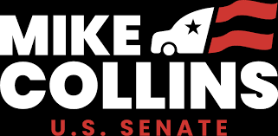

Table of Contents
Aniah Ammah, Gabriel Galindez Rebecca Grossman, Abigail Johnson, Alyssa Langmeyer, & Sid Ram 1
Table of Contents 2
Executive Summary 6
Candidate Profile 7
Mike Collins 7
Background 7
Family 7
Work experience 8
Political Background 9
Major Achievements 9
Stances on Key Issues 12
Affordability/economy: 12
Immigration: 12
Democracy: 12
Abortion: 12
Israel-Palestine: 13
Key Policy Breaks from the Republican Party 13
Syria: 13
Taiwan: 13
Economy: 14
Endorsements 14
Opponent Profile 15
Jon Ossoff 15
Background & Biography 15
Political Career 15
Voting Record & Legislative Highlights 16
Public Image & Brand 18
Key Vulnerabilities 18
Current Political Environment 20
National Political Environment 20
The Economy: 20
Healthcare 20
Democracy 21
National Security 21
Georgia Political Environment 21
Georgia Voter Issues 23
Georgia Election Timeline 25
Targeting 26
Executive Summary 26
MOBILIZE: Turn out 602,753 reliable Republicans who skip midterms. 26
PERSUADE: Win back 356,606 Kemp-but-not-Walker voters in suburban Atlanta. 27
DEFEND: Stay out of Lean Democrat and Strong Democrat counties, except Cobb. 27
The Path to Victory 27
Here is where Collins starts and how far he has to go: 28
The Partisan Landscape: Red Counties, Purple Voters 29
The Kemp-Walker Gap: The Persuasion Universe 30
Cobb County is the biggest persuasion target in Georgia. 31
Per-county persuasion targets 32
Demographic Targets 33
Mobilize counties: Target white men. 34
Persuade counties: Target white women. Secondarily, Hispanic voters in reliably Republican counties. 34
Defensive counties: Watch Black and Hispanic mobilization on the other side. 35
The Targeting Matrix 36
Top Priority Counties 37
Targeting Summary 38
Strategy 40
Overview 40
Theme, Message, & Tone 41
Core Message 41
SWOT Analysis 43
Campaign Analysis 44
Political, Operations, & Finance Staffing 47
Political Staff 47
Operations Staff 48
Finance Staff 49
Coalitions & Surrogates 51
Coalition Groups 51
Surrogates 51
Research & Polling 52
Polling Plan 52
Research Staff 52
Opposition Research 58
Ossoff Research 58
Collins Self-Research (Clean Book) 59
Communications 61
Communications Staff 61
Digital Staff 62
Paid Media 64
Broadcast & Cable 64
Radio 71
Digital Media 75
Earned Media 84
Direct Mail Program Overview 86
Sample Audience Strategy 86
Sample Delivery Schedule & Volume 87
Sample Phase 1: Rural Outreach 87
Sample Phase 2: Suburban Outreach 87
Sample Budget Summary 88
General Audience Strategy for Direct Mail 88
Group 1: Rural White Men (35+) 88
Group 2: Rural White Men (18–34) 88
Group 3: Rural White Women (35+) 88
Group 4: Hispanic Voters 89
Group 5: Younger Suburban White Men (18-34) (Atlanta Media Market) 89
Group 6: Suburban White Women (35–54) (Atlanta Media Market) 89
Group 7: Suburban White Women (55+) (Atlanta Media Market) 90
Group 8: Young Black men (18-34) (Atlanta suburbs) 90
Overall Direct Mail Program Summary 90
Direct Mail - Program Summary 91
Field Plan 93
Field Staff 93
Field Office Geography and Rationale for Placement 97
Field Tactics 99
Budget 101
Total Revenue 101
Revenue Plan 101
Major Donors - 40% of Total Budget ($32,000,000) 101
Fundraising Costs- $640,000 101
Digital Fundraising - 40% of Total Budget ($32,000,000) 104
Corporate and Special Interest PAC Contributions - 12.5% of Total Budget ($10,000,000) 105
Direct Mail- 7.5% of Total Budget ($6,000,000) 106
Expense Allocation by Category 106
Paid Media - $60,458,297 106
Mail & Print- $5,256,000 107
Payroll - $4,568,750 107
Field- $510,500 107
Polling and Research- $879,000 108
Compliance- & Legal $550,000 108
Calendar 110
Appendix 116
Announcement Speech 116

Executive Summary
Mike Collins is a two-term Republican congressman running to unseat Jon Ossoff, a Democratic incumbent in one of the most competitive Senate seats in the country. Georgia has flipped federal offices twice in five years, and the structural problem at the center of Georgia politics has not changed: Republicans win counties and Democrats win voters. Herschel Walker carried more than 70% of Georgia’s rural counties in 2022 and still lost statewide by roughly 37,000 votes. Running up rural margins is necessary but not sufficient for electoral victory. This plan is built around solving both halves of that equation at the same time. Our total expected total turnout for this election is 4,139,248 votes. Our vote goal is 52% of total turnout at 2,152,409 votes.
This election will focus on key issues including affordability, job creation, and public safety. The campaign theme is “Mike Collins is Delivering for Georgia,” and it is not just a slogan but the organizing principle that connects the rural base to the suburban persuasion target voters. Messaging to white, suburban, high-propensity Republican women who voted Kemp and not Walker in 2022 centers Collins as a credible, competent candidate. Collins will distance himself from Trump without disparaging him, align with Governor Kemp wherever possible, and keep the contrast with Ossoff focused on results versus career politics.
The campaign will last from January to November. The total budget for the campaign will be $80 million.

Candidate Profile

Mike Collins

Background
Collins was born in Jackson, Georgia where he grew up and lives to this day. Mike Collins attended Piedmont Academy, a private, college preparational, Christian school near Jackson. He studied a Bachelors of Business Administration at Georgia State University between 1985 and 1990.

Family
Mike Collins is the son of former Republican congressman Mac Collins, who also grew up in Jackson, Georgia and ran a concrete mix business. Mike Collins says he got his first business experience from sweeping floors in his dad’s shop at 12 years old.

Mac Collins served in the Georgia Army National Guard for six years, was Christian and married to his wife Julie for 54 years. Mike Collins' paternal grandfather Henry R. Collins served in World War Two and afterwards founded Collins Concrete Pipe Co. which produced concrete pipe for well casings and driveways, while his paternal grandmother Bessie Britt Collins was the first woman to serve on the Flovilla City Council.

Mike Collins is married to his high school sweetheart Leigh Ann and has three children (Dakota, Dylan and Summer) with seven grandchildren. Him and his wife started a trucking company together in their mid-20s, and they attend Rock Springs Church together, a Methodist church in Milner.

Work experience
Collins has spent all his adult life in the trucking industry, running his own business called Collins Trucking. Collins Trucking started with just one truck and a focus on transporting wood logs, before moving into transporting building products. The company now employs 100 staff including truck drivers, mechanics, dispatchers, and office staff and operates on the outer edge of Jackson, Georgia. It owns over 100 semi-trucks, and operates across the Southeast and Midwest.
Truck drivers at the company earn an average of $1,200-$1,900 per week, above the Georgia average, as well as benefits such as quarterly bonuses, 401K, a drivers lounge, and a driver wellbeing program.
Outside of Collins Trucking, Mike Collins has been the President of the Butts County Chamber of Commerce and Chairman of the Board of Directors for Georgia’s Associated Credit Union. He was also a partner at Quality Tire Recycling from 2002 to 2007.

Political Background
Mike stood for Georgia's 10th congressional district in 2022 and beat Democrat Tabitha Johnson-Green by 64.5% to 35.5%. He is currently serving his second term in this role.
Collins has served on the following House Committees:
- House Committee on Transportation, Water Resources, and Infrastructure
- Subcommittee on Highways & Transit
- Subcommittee on Water Resources & Environment (as Chairman)
- House Committee on Natural Resources
- Subcommittee on Energy & Mineral Resources
- Subcommittee on Oversight & Investigations (as Vice Chair)
- House Committee on Science, Space, and Technology
- Subcommittee on Space & Aeronautics

Major Achievements
Collins introduced the TRANQ Act which passed in 2023. The TRANQ Research Act directs the National Institute of Standards and Technology to deepen its partnerships and strategically focus on the science needed to detect, identify, and better understand synthetic opioids.

Collins sponsored the Laken Riley Act, which he introduced in 2024 and passed in January 2025, one of Trump’s first pieces of legislation passed in his second term. The Act requires US police to detain illegal immigrants without bail while their immigration proceedings are pending if they are charged with theft, shoplifting, or certain other crimes such as drunk driving. It was named after 22 year old University of Georgia student Laken Riley who was murdered by an illegal immigrant previously charged with theft.

Collins has also introduced a range of proposed legislation primarily focussing on small business and immigration. The full list is detailed below.
Legislation | Description | Date Introduced | Status
H.R.8679 – Veterans Opioid Prescription Transmission Bill | Requires the Department of Veterans Affairs to transmit veterans’ opioid prescription histories to community-care providers. | May 7, 2026 | Introduced
H.R.8079 – Diesel Truck Liberation Act of 2026 | Rolls back or limits certain federal emissions regulations affecting diesel trucks. | Mar. 25, 2026 | Introduced
H.R.5258 – Lawsuit Abuse Reduction Act of 2025 | Expands sanctions for frivolous lawsuits and litigation abuse. | Sept. 10, 2025 | Introduced
H.R.4068 – Streamlining NEPA for Coal Act | Streamlines environmental review requirements for coal projects under NEPA. | June 23, 2025 | Introduced
H.R.3900 – Water Quality Technology Availability Act | Addresses access to and standards for water-quality technologies and infrastructure. | June 11, 2025 | Introduced
H.R.3899 – Clarifying Federal General Permits Act | Clarifies federal permitting definitions and procedures. | June 11, 2025 | Introduced
H.R.3898 – PERMIT Act | Streamlines federal permitting processes for infrastructure and environmental projects. | June 11, 2025 | Passed House; pending Senate
H.R.3679 – Small Business Artificial Intelligence Advancement Act | Supports AI adoption and development resources for small businesses. | June 3, 2025 | Passed House; pending Senate
H.R.2662 – Staged Accident Fraud Prevention Act of 2025 | Targets organized staged vehicle accidents and related insurance fraud. | Apr. 7, 2025 | Introduced
H.R.1818 – Aviation Workforce Development Act (119th Congress) | Encourages workforce development and training for aviation careers. | Mar. 3, 2025 | Introduced
H.R.1241 – SAFE for America Act of 2025 | Removes the diversity visa and puts restrictions on sponsoring family members. | Feb. 12, 2025 | Introduced
H.R.1057 – Safe Passage on Interstates Act of 2025 | Addresses interstate transportation safety and criminal enforcement issues. | Feb. 6, 2025 | Introduced
H.R.29 – Laken Riley Act | Requires detention of undocumented immigrants accused of certain crimes. | Jan. 3, 2025 | Passed
H.R.9197 – Small Business Artificial Intelligence Advancement Act (118th Congress) | Earlier version of legislation promoting AI tools and support for small businesses. | July 30, 2024 | Introduced
H.R.8603 – ROAM Act | Public lands and outdoor recreation management legislation. | June 4, 2024 | Introduced
H.R.7083 – RAZOR Act | Allows states to put their own security features on the Mexico border. | Jan. 25, 2024 | Introduced
H.R.4373 – Weather Information for Agriculture Act | Improves weather-data access and forecasting tools for agriculture. | June 27, 2023 | Introduced
H.R.1818 – Aviation Workforce Development Act (118th Congress) | Earlier version of aviation workforce and training legislation. | Mar. 28, 2023 | Introduced
H.R.1734 – TRANQ Research Act of 2023 | Directs research into xylazine and related drug issues. | Mar. 23, 2023 | Passed

Stances on Key Issues
Collins has voted with Republicans on most issues, he has supported Trump since 2016 and is currently quite pro-Trump.

Affordability/economy:
Collins supports reducing federal spending and deregulating so businesses can be more profitable and create more jobs. He champions ‘America first’ policies to give priority to American people and businesses.

Immigration:
Collins takes a hardline approach to illegal immigration, as shown by the Laken Riley Act. He is also supportive of reducing legal immigration, through legislation such as the Security and Fairness Enhancement (SAFE) for America Act of 2025 which would remove the diversity visa program.

Democracy:
Collins has previously stated that ballot boxes were used to fake the election in 2020 to cause Trump to lose and that more scrutiny should be applied to electoral integrity to prevent fraud. He has claimed that the January 6th protestors were peaceful.

Abortion:
Collins is opposed to abortion, believing that life starts at conception.

Israel-Palestine:
Collins supported helping Israel after the October 7th attacks and is broadly supportive of Israel and is dismissive of pro-Palestinian protestors.,

Iran War:
Mike Collins will not break from the Administration in supporting the Iran War. However, Iran War inquiries will be tackled by strategic pivoting that will signal a prioritization of Georgia families and economic issues over endless wars and foreign interests. He may say something to the effect of “President Trump has been a firm supporter of peace through strength, and sometimes this leads to unintended consequences, but I have always prioritized working for Georgia Families.”

Key Policy Breaks from the Republican Party

Syria:
Collins voted to remove troops from Syria in March 2023, which was supported by only 47 Republicans.

Taiwan:
Collins supported arming Taiwan but has opposed providing military support to Ukraine, on the basis that China is a bigger threat to America than Russia.

Economy:
Collins was one of 71 Republicans to vote against the Fiscal Responsibility Act.

Endorsements
Collins has currently been endorsed by the following people and organizations:
- Laken Riley’s family
- National Border Control Council
- The Club for Growth
- Oil and Gas Workers Association
- Senate Conservatives Fund
- Turning Point Action
- Conservative Political Action Conference

Opponent Profile

Jon Ossoff

Background & Biography
Jon Ossoff was born in Atlanta, Georgia, to Heather Fenton, who co-founded NewPower PAC, an organization focused on electing women to local offices in Georgia. Ossoff's father, Richard, was an attorney. Ossoff attended private school before attending Georgetown University, earning a degree in Foreign Service. Later, Ossoff attended the London School of Economics in 2013 to earn his Master’s degree in International Political Economy.

In high school, Ossoff interned for John Lewis, a renowned civil rights activist who mentored him and whom he frequently mentions, describing how Lewis shaped his approach to politics and civil rights. Before entering national politics, Ossoff worked as an investigative media executive and journalist. He became CEO of Insight TWI, a production firm that produced investigative documentaries about organized crime, war crimes, corruption, and human trafficking. In order to present himself as an anti-corruption reformer and an outsider to traditional Washington politics, his campaign message has frequently highlighted this background.

Political Career
Ossoff first gained national recognition with the 2017 special election for District 6 after the resignation of Tom Price. With 48.1% of the vote, Ossoff won the first "jungle primary," but he fell short of the 50% threshold required to prevent a runoff. Later, Republican Karen Handel defeated him 51.8% to 48.2% in the runoff election. Even though he lost, it elevated his recognition within the Democratic party. Later, in 2020, he started to campaign for the U.S. Senate against Republican incumbent David Perdue. A runoff election was needed in January 2021 because neither candidate won a majority vote in the general election in November. In the runoff, Ossoff defeated Perdue to become the youngest Democratic senator elected in decades. With Vice President Kamala Harris breaking the 50–50 split, Ossoff helped Democrats take control of the Senate.

Since being elected into the Senate, Ossoff has served on the Committee on Rules and Administration and the Select Committee on Intelligence. Jon Ossoff has also served on the Senate Committee on Appropriations, which includes the Subcommittees on Agriculture, Rural Development, Food and Drug Administration, and several others. He holds the title of Ranking Member in Veteran Affairs Subcommittees.

Voting Record & Legislative Highlights
Ossoff has kept a voting record that is closely aligned with his party's priorities, while also toeing the line of moderation when it comes to voting. Ossoff has taken part in 122 recorded roll call votes and has voted with his party on significant party-line issues roughly 99% of the time, according to legislative tracking statistics. His voting history shows voting rights protections, federal infrastructure investment, healthcare expansion, climate initiatives, judicial confirmations, and gun safety legislation. Ossoff has also supported important Biden administration policies like the Inflation Reduction Act and the American Rescue Plan Act.

Ossoff has tried to present a more moderate and bipartisan image by supporting measures on public safety like the Laken Riley Act, veterans' programs, military infrastructure, rural broadband development, and anti-corruption oversight. His legislative interests have centered on military and national security issues, government accountability, and law enforcement policies. Conservatives believe that his voting record reflects support for the national Democratic agenda over Georgia's more moderate electorate. Meanwhile, some progressives have questioned his positions on military funding and bipartisan border security measures, claiming that he rules more like a moderate Democrat than a progressive.

Legislation | Description | Date Introduced | Status / Ossoff Vote
Tuberville Amendment #4421 to S. 1383 – “Keep Men out of Women’s Sports” | The amendment would prohibit transgender women and girls from participating in federally funded women’s sports programs under Title IX. | March 21, 2026 | Failed/Opposes
Motion to Table Lee Amendment #4236 to H.R. 7148 – Strike All Earmarks from FY26 Funding Bill | Vote to block Senator Mike Lee’s proposal to remove all earmarks from the FY26 spending package. | January 30th, 2026 | Motion Agreed Too/Supports
H.R. 4 – Rescissions Package Defunding NPR, PBS, and USAID | Bill rescinded federal funding from USAID programs and the Corporation for Public Broadcasting. | July 17, 2025 | Passed Congress/Opposes
Senate Amendment to H.R. 1 – “One Big Beautiful Bill Act” | Republican-backed package focused on border security, federal spending cuts, and public assistance reforms. | July 1, 2025 | Adopted/Opposes
Confirmation of Robert F. Kennedy Jr. as HHS Secretary | Senate confirmation vote for RFK Jr. to lead the Department of Health and Human Services. | February 12, 2025 | Confirmed/Opposes
SAVE America Act | Election integrity legislation requiring proof of citizenship for voter registration. | January 29, 2026 | Stalled/Opposes
Federal DEI Program Restrictions | Legislation aimed at limiting federal diversity, equity, and inclusion initiatives. | 2026 | Pending/Opposes
NGO Defunding Measures | Bills designed to reduce or eliminate federal funding for certain NGOs. | 2026 | Pending/  Opposes

Public Image & Brand
One of Ossoff's greatest strengths is his bipartisan reputation. He frequently describes himself as a pragmatic Democrat concerned with government accountability, ethics reform, and bipartisan cooperation. His investigations into prisoner maltreatment, military housing issues, and corruption have contributed to this image. Georgia Democrats in metro Atlanta, younger voters, Black voters, suburban professionals, and college-educated moderates all strongly favor Ossoff. His campaigns have focused on forming coalitions with Black and suburban Democratic voters.

Key Vulnerabilities
Jon Ossoff's biggest weakness is that Georgia is a competitive battleground, and its voting record is unpredictable. Although he won the 2021 Senate runoff, his margin of victory was close, showing the state's political divisions. Because Georgia is a battleground state, Ossoff must strike a balance between appealing to progressive Democratic voters and keeping support from moderate suburban independents and swing voters. Democrats are also concerned about Ossoff's ability to keep a high turnout and support among Black voters in urban areas without Senator Raphael Warnock on the ballot. Warnock has always led major Black voter mobilization in Georgia.

Ossoff is also seen as removed from common Georgia issues. Republicans can take advantage of his private-school education, international academic background, and career in investigative journalism to portray him as more connected to elite political circles than to working-class Georgia neighborhoods or rural populations. Fundraising has become another source of criticism. Ossoff has received significant campaign funds from donors outside Georgia, primarily Democratic donor networks in California and New York. While supporters see this national fundraising success as proof of widespread Democratic enthusiasm, on the other hand, it might seem like his campaign is mainly backed by out-of-state political interests rather than grassroots Georgia donations.

Current Political Environment

National Political Environment
Election Cycle | #1 Salient Issue | #2 Salient Issue | #3 Salient Issue
2018 | Healthcare | Racial Equality | Private Interests in the Economy
2020 | Economy | Healthcare | COVID-19/Supreme Court Appointees
2022 | Economy | Democracy | Healthcare
2024 | Economy | Democracy | National Security/Immigration

The Economy:
The economy will be a central issue in this campaign. Across the past four election cycles, it has consistently ranked as the most important concern for voters, and Republicans generally perform better when the economy is their central focus.

Healthcare
In comparison to previous cycles, healthcare has lost some of its relative importance. It is more structurally linked with Democratic messaging themes and is typically presented around coverage expansion, government participation, and affordability guarantees, even though it is still consistently important.

Democracy
Over the past two election cycles, democracy has become a much more important subject, yet it acts differently depending on the electorate. It is more likely to resonate with Democratic-leaning individuals and is frequently linked to issues of political norms, institutional trust, and election integrity. Democracy is usually a background issue that influences tone and phrasing.

National Security
One of the stronger subject areas for Republican candidates is national security, which includes parts of immigration and law and order. Republican voters typically favor this category, and it frequently gains importance during times of perceived instability or worry about public safety and border enforcement.

Georgia Political Environment
Since the year 2018, the state of Georgia has become one of the most important swing states in the United States of America. Republicans have consistently held on to state and local offices, while Democrats have increasingly won multiple contests at the federal level. As such, the southern state is cohesively divided between a GOP-led state and highly competitive federal races. In 2018, Republican Brian Kemp won the governor’s race against Democrat Stacey Abrams, while Geoff Duncan secured the Lieutenant Governor’s race and Republican Chris Carr won as Attorney General, after being appointed by Governor Nathan Deal in 2016. Simultaneously, the conservative party maintained control over both the Georgia State House and the Georgia State Senate. At the national level, the Republican Party won 9 of Georgia’s 14 congressional districts, while Democrats won the remaining 5 seats by flipping several districts surrounding the Atlanta area, foreshadowing the major political changes of 2021. Meanwhile, the state saw no scheduled US Senate race in the year 2018, so the two federal seats continued to be held by Republican David Perdue and Johnny Isakson, who resigned due to health reasons in 2019. Following this resignation, Governor Kemp appointed Kelly Loeffler to fill the seat until 2020.

In the year 2020, a major change took place; Joe Biden won the southern state in the presidential election, marking the first time a Democratic candidate won the state since 1992 and designating the state as a battleground race. Fast-forward a year later and the scheduled Senate race of the election cycle prompted two runoff elections in January 2021, as no candidate was able to receive a majority support. Democrats Jon Ossoff and Raphael Warnock won the runoff elections, giving Democrats in Congress a majority. In the U.S. House elections that year, Democrats gained one extra seat by flipping Georgia’s 7th Congressional District in the Atlanta suburbs. Meanwhile, the GOP solidified state-wide control of the government. Governor Kemp won re-election, Burt Jones won the Lieutenant Governor’s race and Attorney General Chriss Carr was re-elected. In 2022, Democrat Raphael Warnock defeated Republican Herschel Walker in the U.S. Senate runoff election, while Republicans retained a majority control of Georgia’s U.S. House seats. In 2024, Donald Trump secured the presidential election. Meanwhile, the US Senate was not up for election and Republicans continued holding a majority of Georgia’s U.S. House seats.

Georgia’s political landscape is partly the product of geographic dynamics. Metro Atlanta and suburban counties have greatly gravitated towards the Democratic Party, particularly amongst college-educated and young voters, while rural Georgia continues supporting the GOP. Black voter turnout and mobilization efforts also have huge implications in making the state more competitive. Simultaneously, since 2018 Georgia has had several statewide referendums and ballot initiatives, mostly focused on issues like tax policy, transportation, homestead exemptions, judicial administration and business courts. While some state’s referendums are brought directly by petition campaigns, Georgia’s ballot initiatives are the product of state legislature action. Georgia’s next major elections will happen this November, when every single statewide constitutional office will be on the ballot, that includes the Governor, Lieutenant Governor, Attorney General, Secretary of State, all seats in the Georgia State House, and the Georgia State Senate. Georgia’s Governor Brian Kemp is prohibited from seeking a third term due to legal constraints, meaning the southern state will have a wide opening for the governor’s position for the first time since 2018. With billionaire Rick Jackson as the Republican candidate for Governor, the Republican nominee for US Senate will need to be aware of potential disruptions to standard fundraising. The state will also hold federal elections, including U.S. House seats and one U.S. Senate election, where Democratic Senator Jon Ossoff’s seat is expected to be one of the most competitive Senate races across the country.

Georgia Voter Issues
Economic concerns are the most compelling issue for Georgia voters in this midterm election. When asked what the most important issue facing Georgia is, approximately 36 percent of voters identified the economy. Comparatively, the same poll revealed 30 percent of voters nationally indicated that the economy was their top concern. This disparity remains consistent across other affordability issues. Housing affordability was the top concern for 14 percent of Georgia voters, but only 4 percent of national voters. Contrastingly, voters in Georgia care less about threats to democracy (11 percent versus the national 30 percent) and immigration (7 percent versus the national 16 percent).
This focus on the economy is promising for Republican success. Recent presidential elections reveal Georgia voters overwhelmingly trust Republican candidates on economic issues compared to Democratic opponents. In 2024, the economy was 40 percent of voters’ top concern, and 76 percent favored Trump on the issue. Similarly in 2020, 36 percent of voters named the economy as the most important issue with an 87 percent favoring Trump on the issue. The difference between presidential and senatorial candidates must not be overlooked, but formidable support for the Republican party on economic issues will be especially useful in this race.

However, this previous support cannot be taken for granted. Voter dissatisfaction with the current economy is reflected onto the Trump Administration, potentially draining support from voters for the Republican party. While the campaign should not closely align itself with Trump, an endorsement would not be fatal. Polling indicates only 12 percent of Georgia voters would be less likely to vote for a candidate endorsed by Trump. Furthermore, 42 percent say an endorsement would have no impact on their vote, and 47 percent would be more likely to vote for the candidate endorsed by Trump.

An endorsement by Governor Kemp would be extremely beneficial in mobilizing base supporters. Kemp is one of the most popular governors in the country with an approval rating of 61 percent. Recently, Kemp signed two major tax relief bills, House Bill 463 and Senate Bill 33, which lowered Georgia’s income and property taxes as well as lowering barriers to construction industry jobs. These actions provide further credibility to Republican actions on the economy, and aligning the campaign with Kemp can glean support from this legislative success.
Another recent event that may influence voter behavior is the recent Supreme Court decision that makes it easier for states to dilute minority votes in redistricting. This decision may be extremely motivating for voters of color who seek to mitigate the impact of the decision by electing Democrats to Congress.

Georgia Election Timeline
March 31st | FEC Q1 Donation Deadline
April 15th | FEC Q1 Filing Deadline
June 30th | FEC Q2 Donation Deadline
July 15th | FEC Q2 Filing Deadline
September 30th | FEC Q3 Donation Deadline
October 5th | Voter Registration Deadline
October 13th | Early In-Person Voting Begins (runs through October 30th)
October 15th | FEC Q3 Filing Deadline
October 23rd | Last day submit Abenstee Ballot application
November 3rd | General Election Day

Targeting
This section is the campaign's roadmap for where to spend money and where not to. Every number in this section comes from the county-level data workbook (159 GA counties, May 2026 voter registration, six election cycles 2018 through 2024). The targeting below guided us to our win number, or 52% of our expected total turnout at 2,152,409 votes.

Executive Summary
Three tactics define this campaign. Each one maps to a specific bucket of Georgia counties, a specific kind of voter, and specific spend strategy.

MOBILIZE: Turn out 602,753 reliable Republicans who skip midterms.
There are 56 counties classified as “Strong Republican with Low or Mid turnout.” They contain 1,319,295 active voters, of whom 602,753 are not projected to show up in 2026. These are people who already vote Republican when they do vote. The campaign's only focus is to get them to the polls. Every dollar spent on turnout here produces a near-guaranteed Collins vote.

PERSUADE: Win back 356,606 Kemp-but-not-Walker voters in suburban Atlanta.
In 2022, 356,606 Georgians cast a vote for Republican Governor (Brian Kemp) but did not cast a vote for U.S. Senate (rejecting Herschel Walker). These voters are already Republican-leaning, but drew a sharp line at Walker. They are concentrated in the college-educated suburban arc around Atlanta: Oconee, Forsyth, Cherokee, Hall, Fayette, and Cobb counties. These voters do not need to be converted from Democrat to Republican; they need to be re-unified with the Republican ticket. That is a meaningfully lower bar than persuasion from scratch.

DEFEND: Stay out of Lean Democrat and Strong Democrat counties, except Cobb.
Georgia's “Lean Democratic” and “Strong Democratic” counties together hold 3,749,141 active voters, about 51% of the state. But because Republican vote share in those counties is low, they only produce a small fraction of Collins' projected total. Money spent on turnout in these counties activates Ossoff voters more than Collins voters. The one exception is Cobb County, which is technically a “Lean Democrat” county, but holds the single largest persuasion pool in the state (35,131 split-ticket voters). Cobb County is a Democratic county worth investing in for the purposes of persuasion.

The Path to Victory
Georgia uses a 50%+1 rule. If no candidate clears that threshold on November 3, the top two finishers go to a December 1 runoff. The campaign is targeting 52% as a safe cushion and to, ideally, avoid a runoff.
52% of our expected total turnout is 2,152,409 votes. This is what the campaign should plan for. It absorbs late polling shifts, a bad debate night, or an Ossoff late ad buy. Planning to win 50% + 1 leaves no margin while 52% does. The graph below illustrates the difference between 51% and 52% of the total vote share, and why shooting for 51% is a precarious position to be in.
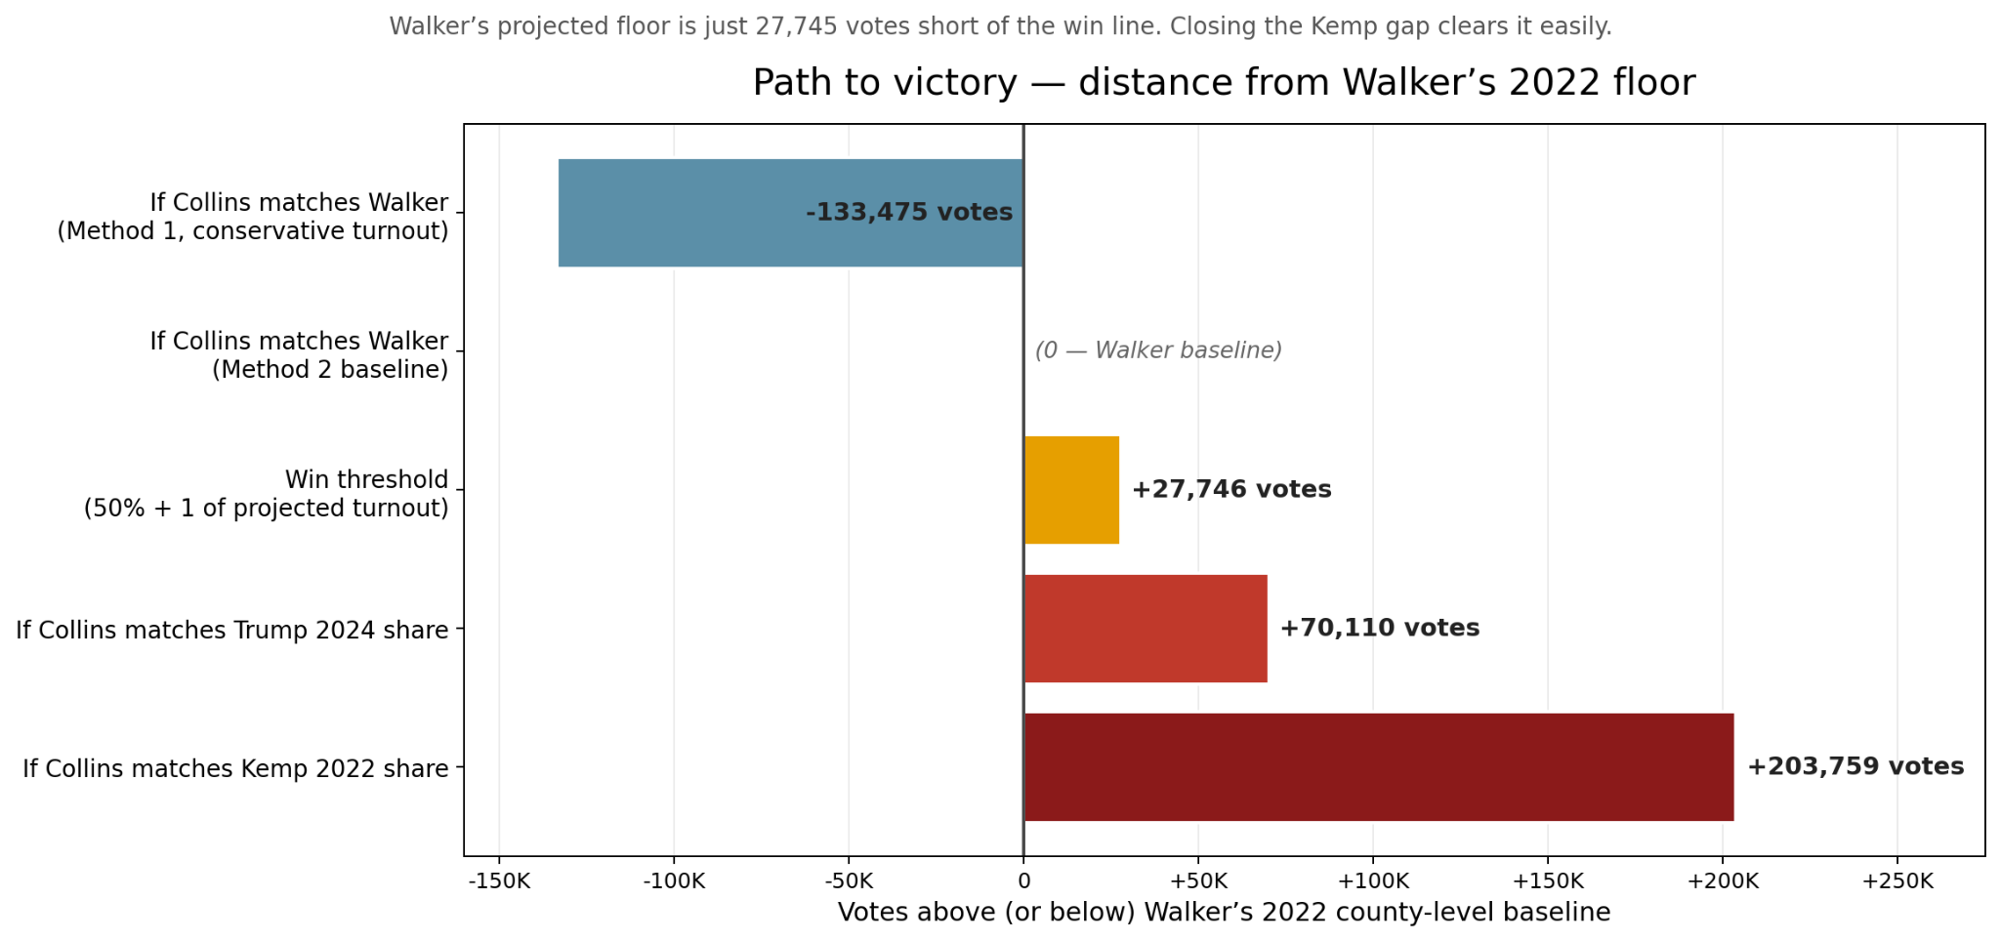

Here is where Collins starts and how far he has to go:
If Collins exactly matches Walker's 2022 county-by-county Republican share, the floor scenario, the model projects 2,041,879 Republican votes. That leaves a gap of 27,746 votes to clear the 50%+1 threshold and 110,530 votes to clear 52%. The campaign closes that gap through some combination of (1) mobilization in Strong Republican counties where Republican voters skipped 2022, and (2) persuasion in suburban Atlanta where Republican voters split their ticket. The math: if the campaign can convert 31% of the 356,606-voter persuasion universe, that alone covers the gap to 52%.

The Partisan Landscape: Red Counties, Purple Voters
Georgia has 159 counties. Of those, 94 are “Strong Republican,” which is 59% of all counties, but only 34.2% of active voters (2,515,990). At the other end, 22 counties are “Lean Democrat” or “Strong Democrat” (14% of counties), but they hold 51% of active voters (3,749,141).
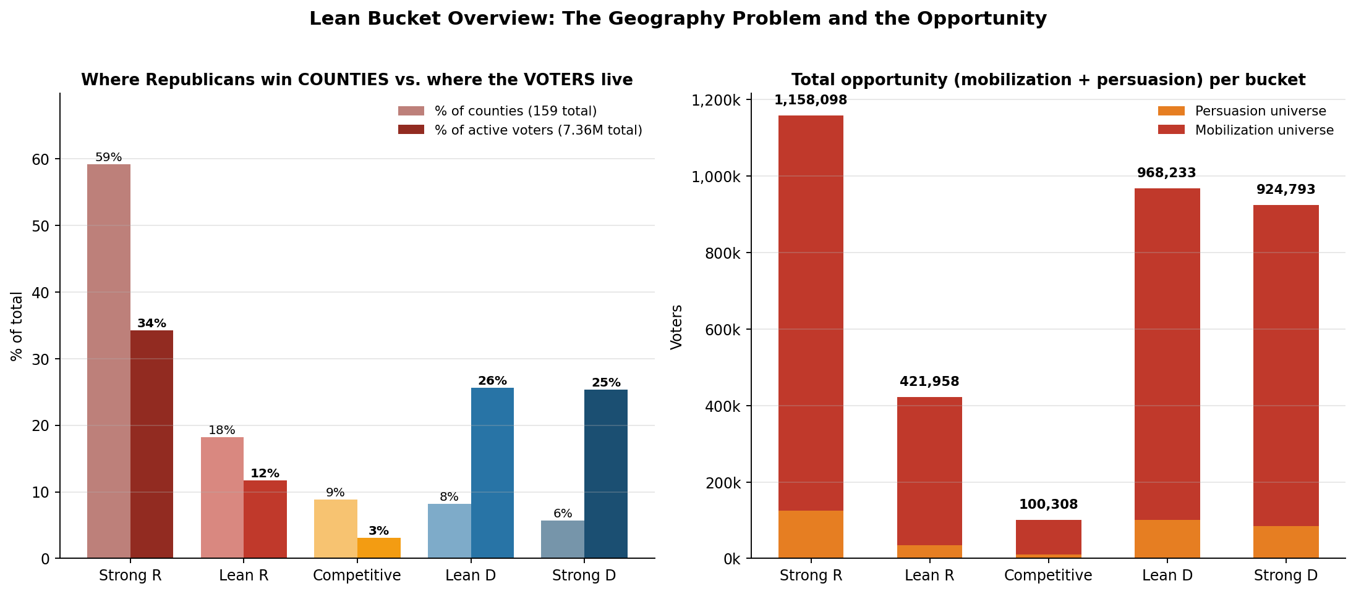
Republicans win the most counties but Democrats hold the most voters. The persuasion plus mobilization opportunity is largest in “Strong Republican, but Lean Democrat” matters because of sheer population size.

This is the geography problem at the center of every Georgia Republican Senate race. Walker carried more than 70% of counties in 2022 and still lost statewide by roughly 37,000 votes. Running up margins across rural Georgia is necessary but not sufficient. Collins also has to limit his losses in Atlanta. The targeting plan in this section is structured around both halves of that equation.
Lean Bucket | Counties | Active Voters | % of Active Voters
Strong R | 94 | 2,515,990 | 34.2%
Lean R | 29 | 862,633 | 11.7%
Competitive | 14 | 228,268 | 3.1%
Lean D | 13 | 1,884,016 | 25.6%
Strong D | 9 | 1,865,125 | 25.4%

The Kemp-Walker Gap: The Persuasion Universe
The single most important metric in this analysis is the Kemp-Walker gap. In 2022, Georgians voted for governor and U.S. senator on the same day, on the same ballot. Kemp won the Governor's race with 53.4% of the vote. Walker lost the Senate race with 48.5%. That is a 4.9-point statewide gap between two Republicans on the same ballot, and at the county level the gap is much wider in some places than others.

Those split-ticket voters, people who chose the Republican for Governor but not for Senate, are the persuasion universe. Statewide, the persuasion pool is roughly 356,606 voters. They are not Democrats. They are not Independents who need to be converted. They are Republican-leaning voters who voted Republican for one office on one day and refused to vote Republican for another office on the same day. The task is to re-unify a ticket that split, not to flip voters across party lines. That is a meaningfully easier persuasion job.
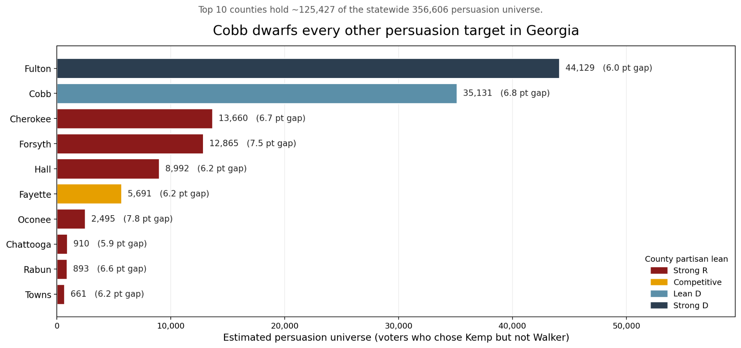
The counties with the biggest gaps cluster in the wealthy, college-educated suburban ring around Atlanta. This is not speculation; it matches every external account of the 2022 race. CNN's pre-election coverage described "white suburban Republican leaners for whom voting for Walker is a bridge too far" as the defining 2022 demographic. The New York Times found Kemp ran 20 points ahead of Walker in the wealthy northern Atlanta suburbs. The persuasion playbook is to give those voters a Republican Senate candidate they can vote for in good conscience, which means the campaign messaging has to draw a sharp distinction between Collins and Walker, not lean into a shared brand.

Cobb County is the biggest persuasion target in Georgia.
Cobb County is technically classified as “Lean Democrat” (partisan blend 41.38%), but its 6.82-point Kemp-Walker gap across 515,118 active voters produces a persuasion universe of 35,131 voters. That single county is bigger than the active voter population of most Georgia counties combined and is almost as large as Walker's entire 2022 statewide loss margin. Cobb County is the one place in the “Lean Democrat” bucket where the campaign should spend persuasion dollars.
County | K-W Gap (pts) | Lean Bucket | Active Voters | Persuasion Universe
Oconee | 7.76 | Strong R | 32,157 | 2,495
Forsyth | 7.54 | Strong R | 170,617 | 12,865
Cobb | 6.82 | Lean D | 515,118 | 35,131
Cherokee | 6.65 | Strong R | 205,421 | 13,660
Rabun | 6.59 | Strong R | 13,553 | 893
Hall | 6.21 | Strong R | 144,801 | 8,992
Fayette | 6.2 | Competitive | 91,783 | 5,691
Towns | 6.16 | Strong R | 10,737 | 661
Fulton | 5.95 | Strong D | 741,659 | 44,129
Chattooga | 5.91 | Strong R | 15,399 | 910

Per-county persuasion targets
The targeting workbook turns the statewide persuasion universe into a per-county operational number. Column J in the Summary tab calculates, for each of the 159 counties, the specific number of Kemp-but-not-Walker voters the campaign must convert to close the gap to 52%.
Rank | County | Market | Persuasion Universe (col G) | Target to Convert (col J) | Total County Target (col K)
1 | Fulton | Atlanta | 44,129 | 13,680 | 118,685
2 | Cobb | Atlanta | 35,131 | 10,891 | 139,063
3 | Gwinnett | Atlanta | 35,034 | 10,861 | 127,713
4 | DeKalb | Atlanta | 20,691 | 6,414 | 47,826
5 | Cherokee | Atlanta | 13,660 | 4,235 | 94,823
6 | Forsyth | Atlanta | 12,865 | 3,988 | 74,554
7 | Chatham | Savannah | 10,369 | 3,214 | 46,795
8 | Hall | Atlanta | 8,992 | 2,788 | 60,939
9 | Henry | Atlanta | 6,641 | 2,059 | 36,483
10 | Coweta | Atlanta | 6,411 | 1,987 | 48,437

Demographic Targets
Base | Persuade
Rural white women | Younger white men
Older white women | Younger men of color (spec. Black and Hispanic)
Rural white men | Suburban Atlanta white women
Older white men | –

The campaign’s overall electorate is about 53.6% white, 29.1% Black, and 6.1% Hispanic and Asian. But those shares change sharply by lean bucket and turnout tier. The demographic composition of the actual target universe, the voters Collins needs to mobilize or persuade, looks meaningfully different from the statewide average.
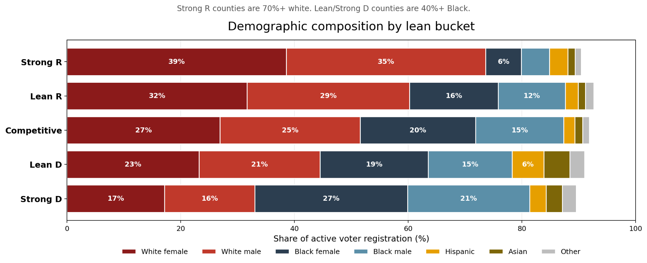

Mobilize counties: Target white men.
The 56 “Strong Republican” Mobilize counties are 73.4% white by active voter registration. In 2020, white women in those counties turned out at 38.7%; white men turned out at 34.1%, a 4.6-point gap. White men are the highest-volume under-mobilized group in the Republican base. Field, mail, and radio in these counties should be designed around getting them to the polls.

Persuade counties: Target white women. Secondarily, Hispanic voters in reliably Republican counties.
The Kemp-Walker gap counties are 40% to 47% white women by registration, already high-propensity voters. The gap there is not turnout, it is candidate preference. The persuasion target is specifically the white, suburban, high-propensity Republican women who voted for Kemp and either skipped or crossed over in the Senate race in 2022. Messaging has to be about Collins as a credible, competent Republican, to subtly contrast Collins against previous Senate candidate Herschel Walker.

A secondary target exists in Hall, Whitfield, and Barrow counties, where roughly 29,582 Hispanic voters are registered in reliably Republican counties but turned out at just 7% to 13% in 2020. These are working-class, often Catholic, economically conservative voters with no strong partisan attachment. The message to these voters should be economic and community-safety focused, not immigration-heavy.

Defensive counties: Watch Black and Hispanic mobilization on the other side.
The 7 “Lean Democrat + Low Turnout” counties hold a mobilization universe of 578,276 voters, approximately 35% Black, 12% Hispanic, and 41% white by registration. Black women in Georgia outperformed Black men by 6.06 points in 2020 turnout, meaning Black men and Hispanic voters are the most under-mobilized segments of the Democratic base. They are also the most likely focus of Ossoff's ground game. The campaign should not invest in turnout here, however could run anti-Ossoff ads to demobilize these voters from going to the polls.

The Targeting Matrix
Every county in Georgia is classified by partisan lean (“Strong Republican” through “Strong Democrat”) and projected turnout tier (Low / Mid / High). Each combination produces a recommended action. This is the single most useful tool in the targeting workbook: given a county, the cell tells the campaign exactly what to do with its budget there.
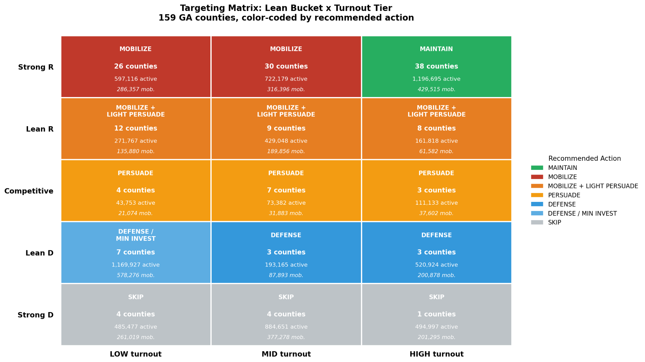
The 56 “Strong Republican + Mobilize” cells (Low and Mid turnout combined) hold 1,319,295 active voters with a combined mobilization universe of 602,753. These voters do not need persuasion. They are reliable Republicans who skip midterms. Mobilization spending here produces near-guaranteed Republican votes with no persuasion risk.
The 7 “Competitive + Mid Turnout” counties are the persuasion sweet spot. Close enough that messaging moves the margin, engaged enough that voters are reachable, but not so saturated that they are already locked in.

A counterintuitive finding: the largest absolute pools of persuadable voters are inside “Strong Republican” and “Lean Democrat” counties, not “Competitive” ones. “Strong Republican” counties hold 125,830 of the 356,606 statewide persuasion universe (35%); “Lean Democrat” holds 101,186 (28%); “Strong Democrat” 85,201 (24%); “Lean Republican” 34,640 (10%); and “Competitive” only 9,749 (3%). The “Competitive” bucket has the smallest pool because it has the fewest total voters. Collins should focus persuasion inside the “Strong Republican” Atlanta urban edge counties with large Kemp-Walker gaps, not just the narrow 14-county Competitive tier.

The 7 “Lean Democrat + Low Turnout” counties are the most defensive cell of the matrix. They contain 1,169,927 active voters with a mobilization universe of 578,276 people not currently projected to vote. That is a sleeping giant for Ossoff. The campaign should not spend on turnout here. The play is to monitor the Ossoff ground game and adjust if the sleeping giant starts waking up.

Top Priority Counties
The full priority ranking is in the data workbook. The top 10 counties by composite priority score are below. Priority score weights mobilization universe and persuasion universe together, weighted by each county's strategic value: “Strong Republican” counties weight mobilization heaviest, “Competitive” counties weight persuasion heaviest.
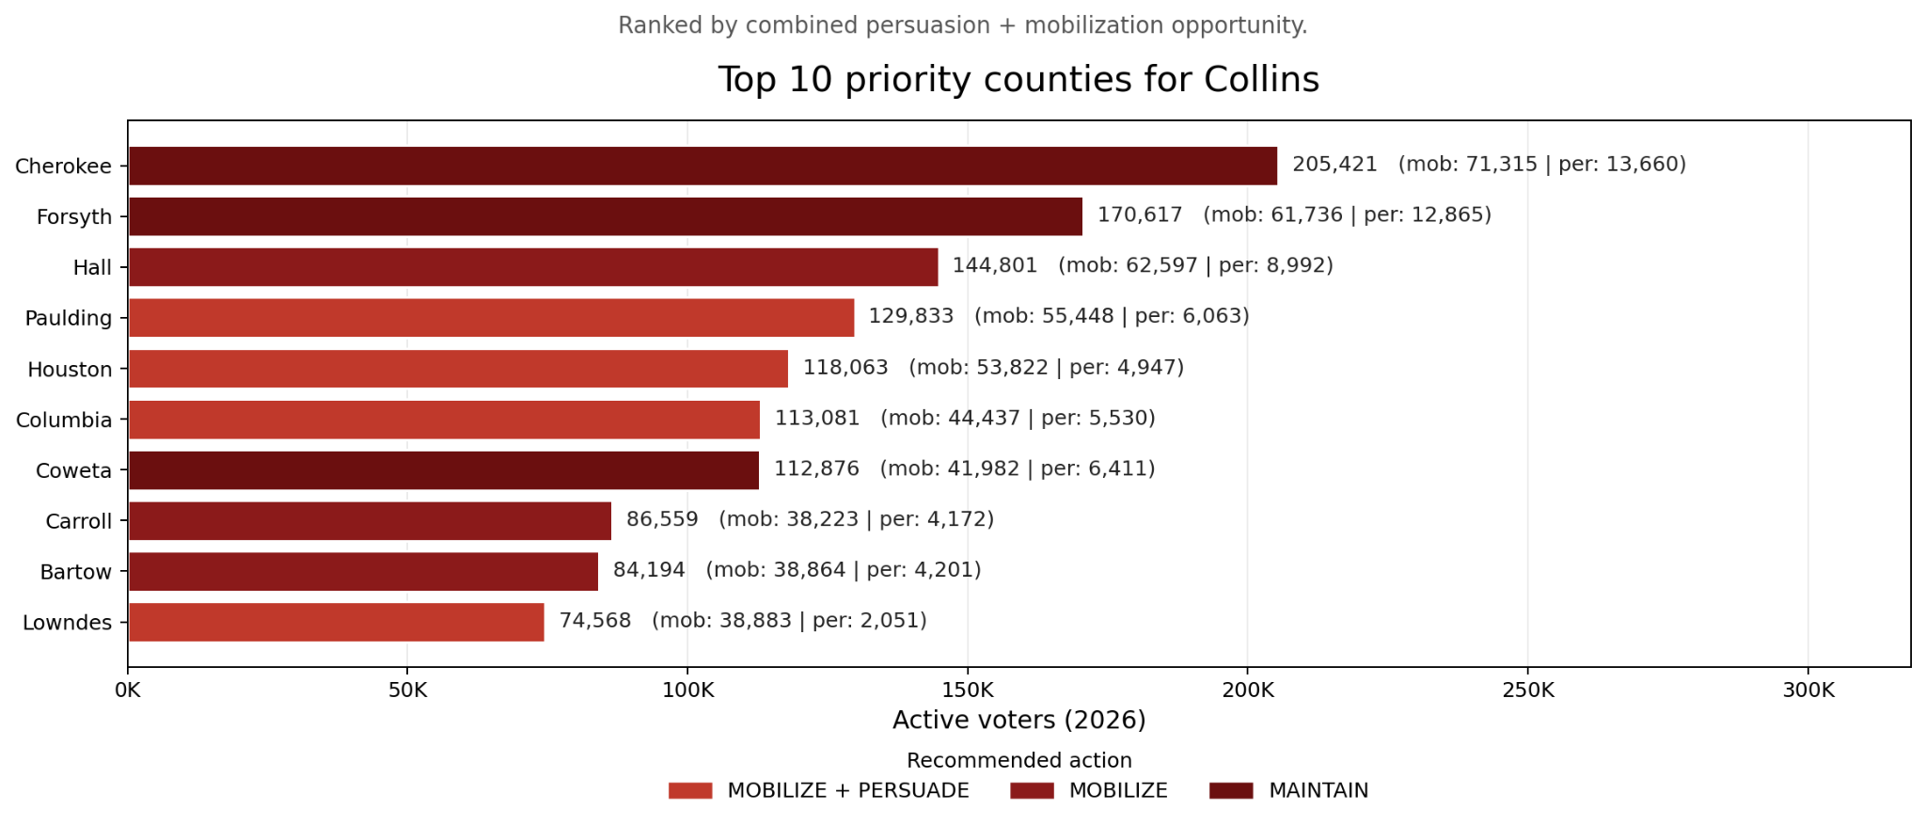
Rank | County | Lean | Turnout | Action | Active Voters | Persuasion | Mobilization
1 | Cherokee | Strong R | High | MAINTAIN | 205,421 | 13,660 | 71,315
2 | Forsyth | Strong R | High | MAINTAIN | 170,617 | 12,865 | 61,736
3 | Hall | Strong R | Mid | MOBILIZE | 144,801 | 8,992 | 62,597
4 | Paulding | Lean R | Mid | MOBILIZE + LIGHT PERSUADE | 129,833 | 6,063 | 55,448
5 | Houston | Lean R | Mid | MOBILIZE + LIGHT PERSUADE | 118,063 | 4,947 | 53,822
6 | Columbia | Lean R | High | MOBILIZE + LIGHT PERSUADE | 113,081 | 5,530 | 44,437
7 | Coweta | Strong R | High | MAINTAIN | 112,876 | 6,411 | 41,982
8 | Bartow | Strong R | Low | MOBILIZE | 84,194 | 4,201 | 38,864
9 | Carroll | Strong R | Mid | MOBILIZE | 86,559 | 4,172 | 38,223
10 | Lowndes | Lean R | Low | MOBILIZE + LIGHT PERSUADE | 74,568 | 2,051 | 38,883

Targeting Summary
The Collins campaign runs as the de facto Republican nominee from January 1, 2026 through November 3, 2026: ten months of general election against incumbent Jon Ossoff with no primary to fight. This targeting plan above structures those ten months around three tactics.

Mobilization is the dominant spend in the “Strong Republican + Mobilize” cells, 56 rural and small-metro counties where 602,753 reliable Republicans need a reason to show up. Persuasion concentrates on the suburban Atlanta arc (Oconee, Forsyth, Cherokee, Hall, Cobb, Fayette counties), where 356,606 Kemp-but-not-Walker voters are the swing pool, with per-county conversion targets specified in column J of the Summary tab. Defense means staying out of “Lean Democrat” and “Strong Democrat” counties (Cobb County excepted), and monitoring early-vote return rates among Black men and Hispanic voters as the leading indicator for Ossoff's GOTV operation.

If Collins exactly matches Walker's 2022 county-by-county Republican share, he ends up at 2,041,879 votes. That is short of the 50% threshold to avoid a runoff, and well short of the 52% 2,152,409 target. The campaign closes that gap by outperforming Walker, through persuasion in suburban Atlanta, mobilization in rural Georgia, or both. The targeting framework in this section is the operational plan for outperforming the floor.

Strategy

Overview
During this campaign, we are focused on issues Georgians should care about when it comes to electing their next leader. To hit our 52% goal of 2,152,409 voters, we plan to maximize turnout with the traditional conservative voters by running a Kemp-not-Walker campaign, while also cutting into Democratic margins in the Metro Atlanta area. Our field offices will be located in high priority counties to ensure we are easily reaching the counties most necessary for victory. We want to retain and gain, while slashing and demobilizing the Democratic base. The five key aspects to keep the race competitive are:
- Mobilize Republican voters who voted for Kemp but did not support Walker
- Persuade suburban swing voters, especially white women in the suburbs of Atlanta who are concerned about affordability and public safety
- Increase Republican margins in rural Georgia
- Reduce Democratic turnout intensity in heavily Democratic urban areas
- Present Collins as a working-class conservative focused on putting Georgia first, unlike the career politicians leading our state.

Theme, Message, & Tone
“Mike Collins is Delivering for Georgia” is the theme we will push throughout the campaign. It communicates a plan of action, effectiveness, and loyalty to the local audience. This positions Collins as someone who is focused on producing results rather than engaging in partisan conflict for his own gain. It allows the campaign to appeal to both conservative rural voters and suburban moderates who may be frustrated with national politics.

The broader narrative behind the phrase emphasizes Collins' past as a business owner and a conservative outsider who understands what everyday Georgians are going through. The campaign will frame him as someone focused on lowering costs, creating jobs for Georgians, reducing crime, and protecting local small businesses. Instead of engaging in a full-blown partisan war, we will ensure the message focuses on Collins's competence, reliability, and responsiveness to Georgia’s needs. The theme of the campaign must be confident and disciplined. We will not fall for partisan bait when it comes to Ossoff. This campaign is not against the current administration, but we will not rely on the administration to gain votes.

Core Message
Our core message centers on presenting Collins as a hands-on fighter who understands the daily struggles of his people. He will challenge leaders in the Senate to “Keep Georgia Strong.” This slogan is intended to mobilize the always Republican voter, but is distanced from “Make America Great Again” to not dissuade swing voters. Another message frame that will be sprinkled throughout the campaign is: “Mike Collins is delivering for Georgia by fighting for lower costs, protecting communities, strengthening businesses, and putting Georgia families first. Collins is focused on results that will always benefit the people of Georgia”.

Message Bucket 1: “Fighting for Affordability” focuses on the economic frustrations many people in Georgia are facing. The campaign is focused on lowering everyday costs, protecting families, reducing inflation within the state, and pushing the idea of reducing reckless federal spending that is hurting the pockets of Georgians. This bucket is important so we can target suburban voters and middle-class swing families concerned about rising costs.

Message Bucket 2: “Fighting for Georgia Jobs” will highlight Collins' business background and frame him as a candidate focused on economic growth. The campaign will stress the importance of protecting Georgia industries, supporting small businesses, strengthening infrastructure, and resisting regulations that are killing business in the state. This bucket will target working-class voters, rural communities, and business-focused suburban moderates.
Trump
Collins will not explicitly align himself with Trump, he will not proactively mention Trump, and will stay away from “MAGA” branding in his communications. However, Collins will not disparage Trump, and will show support for the issue priorities of the current administration. This will address Trump’s declining popularity amongst swing voters, especially on the economy, which is the biggest issue to Georgia voters.

SWOT Analysis
STRENGTHS  - Established Republican  - Successful small business owner in a working class industry (trucking) which operates out of his hometown and employs Georgia locals.  - Looks like our core target demographic, a 58 year old white man from regional Georgia with a hands-on job.  - Long family history in Georgia, with parents and grandparents operating small businesses and being elected representatives.  - Family history of military service.  - ‘Family man’ perception with his wife, multiple children and grandchildren living in Georgia.  - Passed the Laken Riley Act based on crime in Georgia.  - Introduced legislation to the House that supports truck drivers, veterans, and small business owners, which are target groups.  - Christian alignment with regular attendance of a Methodist church.  - Only two terms as a House representative, not a career politician.  - Endorsed by workers groups such as the Oil and Gas Workers Association.  - Endorsed by the National Border Patrol Council, which reflects his commitment to keeping Georgia safe. | OPPORTUNITIES  - Affordability is the biggest concern to Georgian voters, and can frame efforts to reduce immigration as reducing inflationary pressure especially on housing.  - The economy and job availability is one of the biggest concerns to Georgia voters. Collins has a background in small business; creating jobs and supporting deregulation, such as introducing the Diesel Truck Liberation Act, with the intent to create jobs.  - Collins has introduced legislation to improve AI uptake with business, which could lead to donations from AI companies.  - The race is a statistical tie using our projection estimation, Collins is not at a material disadvantage.  - Senator Raphael Warnock is not on the ballot, so Black Democrat voters may be less motivated to turn out to vote.
WEAKNESSES  - Collins has been closely aligned with Trump, who is falling in popularity amongst swing voters in Georgia, so Collins will need to distance himself from Trump without explicitly saying he doesn’t support him.  - Trump’s favourability is particularly low on the issue of affordability, which is the biggest issue to the people of Georgia.  - Collins Trucking company has a worse than average record for deadly crashes and non-compliance with truck registration, putting Georgians at risk.  - Collins’ Chief of Staff is currently under investigation for the misuse of congressional funds.  - His Chief of Staff was also hired despite having a violent criminal record.  - Lower name recognition as a congressional representative standing against an incumbent.  - Previously misspelled "Georgia” in a campaign ad. | THREATS  - A large chunk of the Republican base did not turn out to vote for Herschel Walker in 2022, who was endorsed by Trump and Mitch McConnell. Mobilization of the Republican base is a crucial element of the strategy to win.  - Projected lower campaign fundraising compared to Ossoff campaign.  - Incumbency bias for Jon Ossoff.  - Ossoff leads Collins by 16 points with Independents, by 12 points with younger voters (under 50), and by 8 points with women. Our target demographics are older men and white women.

Campaign Analysis
COLLINS on COLLINS (STRENGTHS)  - Cares about Georgia businesses and jobs, and is a small business owner.  - Strong connection to Georgia as his family have lived there for generations  - Competent leader, has run a business with 100 employees and been on the Board of Trustees for various organizations.  - Relatable to voters and understands them due to his background as a truck driver.  - Relatable to voters, especially women, due to having a family and many grandchildren.  - Christian and regular church attendee, showing same values as majority of Georgia residents who identify as Christian.  - Legislative record of passing the Laken Riley Act, one of the first pieces of legislation signed by Trump in his first term showing his legislative effectiveness.  - Legislative record of passing the TRANQ Act under Biden, showing an ability to work with both sides to achieve results.  - Legislative record of introducing legislation to reduce regulation, support businesses,veterans, and aviation personnel.  - Has cast some votes against providing military aid to Ukraine and Israel, keeping money in the USA for Americans. | COLLINS on OSSOFF (OPPORTUNITIES)  - Ossoff’s background is as a journalist, he hasn’t had a real job working with his hands or delivering a service to people in Georgia, he is an unrelatable and elite ‘pretty boy’.  - He moved out of Georgia as a young adult and has worked overseas, he is not committed to Georgia and only returns when convenient.  - Ossoff voted for the Fiscal Responsibility Act 2023 which increased the maximum age for work requirements for SNAP benefits from 49 to 54. This will remove eligibility for some older people who do not meet the work requirements.  - Ossoff was quite supportive of Biden, speaking at his campaign rally in Atlanta in 2024, which may alienate voters who didn’t like Biden.  - Born in inner Atlanta and spending most of his life living in cities like London, he has no understanding of what living in rural and small town America is like.  - Ossoff is the incumbent and has been in politics since 2017. He is a career politician and part of the bureaucracy.  - Ossoff almost always votes with the Democrats to serve their interests, he is not thinking independently about how to help the people of Georgia.  - Ossoff’s mother is Australian and he previously had Australian citizenship, some people may question his commitment to America.  - While Ossoff voted for the Laken Riley Act, he was bandwagoning off of Collins and didn’t take the initiative to introduce the Bill first.  - Ossoff voted for the Laken Riley Act, progressive Democrats may not want to vote for him for this reason.  - Most of Ossoff’s donors are from liberal states like California and New York, he is bankrolled by elites disconnected from Georgia.  - Elected in his thirties, Ossoff lacks the life experience necessary to be an effective representative.  - He is more interested in appealing to kids on TikTok than talking to adults in Georgia about the real issues.  - Ossoff has an inconsistent record on providing arms to Israel.
OSSOFF on COLLINS (WEAKNESSES)  - Collins is closely aligned with President Trump, who is unpopular and has low approval ratings for the things Georgians care about.  - Collins can’t be trusted to be anti-corruption, after his Chief of Staff fraudulently used congressional funds.  - Collins doesn’t support family unification for immigrants, sponsoring the SAFE for America Act to prevent some visa recipients from bringing their families to the US.  - Has cast some votes in support of sending arms to Israel and Taiwan, sending US money offshore.  - Collin’s business has had trucks fail safety ratings, he doesn’t care about worker safety he only cares about them benefitting the business.  - Collins has voted to maintain tariffs on countries like Canada, while other Republicans crossed the floor, which impacts affordability for Georgians. | OSSOFF on OSSOFF (THREATS)  - Ossoff has had a varied career and worked in anti-corruption, bringing international experience to the role of Senator.  - He was born and raised in the suburbs of Atlanta, attending local schools in the area.  - Ossoff has a wife and two young children, relating to the everyday families of Georgia who are concerned about the future for their kids.  - Dr Alisha Kramer, Ossoff’s wife, is a certified OBGYN in Atlanta who sees the realities of healthcare in Georgia every day.  - Ossoff has a significant legislative record during his first term in office, passing multiple bills about child safety.  - Ossoff has also introduced many bills to support different demographics, including tax deductions for farmers and small businesses, housing loans for veterans, and rebates for clean energy  - Ossoff reintroduced the Ban Congressional Stock Trading Act.

Political, Operations, & Finance Staffing

Political Staff
Campaign Manager - $17,500/Month
The Campaign Manager will be among the first hires, as they will set the tone for the campaign and drive the hiring decisions for many of the other leadership positions on the campaign. They will be hired in January.

Deputy Campaign Manager - $16,250/Month
The Deputy Campaign Manager will be hired in March, allowing the Campaign Manager time to understand the campaign environment before making this hire.

Political Director - $15,000/Month
The political director will be hired in March to help shape the direction of the campaign as it picks up in the second quarter.

Policy Director- $15,000/Month
The Policy Director will be hired in January to shape policy priorities and help the Campaign Manager understand the political environment and make early decisions.

Operations Staff
Director of Operations - $15,000/Month
The Director of Operations will be hired in January to support the operations of the office and campaign initially.

HR Director - $15,000/Month
The HR Director will be hired in January to support the hiring of other positions later in the campaign. They will interface between all staff and the Campaign Manager to manage any potential interpersonal issues between employees.

Director of Scheduling & Advance - $15,000/Month
The Director of Scheduling and Advance will be hired in April as the campaign picks up and the candidate begins to travel and campaign more extensively. This role will be performed by the Director of Operations until this hire is made.

Scheduler - $7,500/Month
The Scheduler will be hired in April and will work under the Director of Scheduling and Advance. The Scheduler will create the Candidate’s daily schedule as it becomes busier with campaign commitments.

Advance Lead (2) - $7,500/Month/Employee
The first Advance Lead will be hired in June and a second one will be hired in August to support the candidate as he participates in more events as the campaign grows.

Body Person - 5K/Month
The Body Person will be hired in January and will support Mike Collins throughout the entirety of the campaign. The body person is Collins personal aide who will attend all events with him and travel with him everywhere he goes on the campaign trail. The body person will start work in January as the person needs to be able to assist Collins from the beginning of the campaign.

Tracker (2) -5K/Month/Employee
The tracker’s role is to follow Jon Ossoff for the duration of the campaign to the extent that they can, attending all his public events, recording and taking notes of what he and his team does. The first will be hired from January and the second in June, who will be stationed in a different part of Georgia, based on where Ossoff is doing the most of his campaigning.

Finance Staff
Finance Director - $15,000/Month
The Finance Director will be hired in January to manage all incoming and outgoing finances throughout the entirety of the campaign. The Finance Director will manage all fundraising aspects of the campaign: major donor, digital, and direct mail. They will oversee in and out of state events, travel, and overall outreach strategy. They will also oversee the budget to ensure cashflow is steady throughout the campaign.

Deputy Finance Director - $13,750/Month
The Deputy Finance Director will be hired in April after the close of the first quarter to support the Finance Director in managing incoming and outgoing funding.

Call Time Manager - $12,500/Month
Mike Collins will participate in call time consistently. His Call Time Manager will be hired in January to support this effort throughout the entirety of the campaign. The Call Time Manager will be responsible for ensuring that time is held for Call Time at regular intervals and that the Candidate is provided with updated donor prospects and contact information that will yield positive fundraising outcomes.

Events Manager- $12,500/Month
The Events Director will be hired in January to support fundraising events both in-state and in other states throughout the entirety of the campaign.

Finance Assistant - 5,000/Month
The Finance Assistant will be hired in April, after the end of the first quarter. The Finance Assistant will support the Finance Director, Deputy Finance Director, and Call Time Manager with the implementation of the fundraising plan. Responsibilities include, but are not limited to, assisting with call-time, overseeing fundraising events, and documenting fundraising activities.

Coalitions & Surrogates

Coalition Groups
Collins has natural supporters in conservative advocacy groups that our target mobilize and persuade voters are likely to support. We will actively look to form relationships with these groups to have them encourage their supporters to vote for Collins, and in some cases seek formal endorsement from them.
Advocacy groups aligned with Collins’ views such as Georgia Second Amendment (pro-firearms), and Georgia Right to Life (anti-abortion) are ideal to target for collaboration on volunteers and resources. The Georgia Chamber of Commerce has also previously endorsed Republican candidates for Senate, so we may seek endorsement from them because Collins’ major issues are the economy and supporting small business.

Surrogates
The primary surrogate we will seek to join us will be Governor Brian Kemp as he is the most popular Republican in the state. By using him as a messenger and supporter of Collins we will counteract the anti-conservative sentiment brewing because of the Trump Administration. Kemp will join us at an event in the Atlanta suburbs specifically because that is a key area where we will need to drive up support to reach our 52% goal.

Research & Polling

Polling Plan
This polling and focus groups plan creates the base for informed decision-making and media choices for the 2026 Georgia Senate race in order to reach a 52% victory threshold of 2,152,409 votes. The research polling identifies where persuasion is possible, turnout is optimized, and message is the most effective. The research focuses on three core electorates: suburban Republican-leaning counties where ticket splitting occurred in 2022, rural conservative counties that highly drive turnout, and metro Atlanta counties where Democratic margins dominate, for defensive measurement, with Cobb County treated as the strongest persuasive opportunity in the area. The primary strategic universe centres on the Kemp-Walker split voter set, that is voters who backed Governor Kemp in 2022 but did not support the GOP Senate candidate. These voters are concentrated in Oconee, Forsyth, Cobb, Cherokee, Hall, and Fayette counties.

Research Staff
Director of Research - $15,000/Month
The Director of Research will be hired in January to support the production of the self and opposition research books. The Director of Research will oversee the research strategy for the campaign, including managing two research assistants and the relationship with the polling consultant. The Director of Research will start in January to get a start on the research necessary for the campaign.

Research Assistants (2) -$5,000/Month/Employee
The research assistants will both be hired in April to conduct research, including continuing to collect opposition research on Ossoff throughout the campaign.

Polling Design: Budget $700,000
All quantitative polling will be conducted through live-interviewer telephone surveys using voter file samples. Each benchmark is N=1200, the minimum for statewide election. Live phone interviewing will be the primary method of polling usage, while IVR and online opt-in polling will be excluded due to the high distortion risks. Media polling will not be used.

Benchmark ($100,000/ Each) Calendar: $200,000
This calendar outlines the research program with specific campaign objectives.
- The February 2026 Benchmark focuses on issue saliency and measures the mood of the voters. Issue saliency will determine what is driving voter behaviour and defining the overall voter environment.
- The June 2026 Benchmark will focus on message testing to establish core persuasion priorities before we go on TV to make sure our message is well-received, accurate and persuadable ahead of heavy expenditure.

Baseline ($75,000/ Each) Calendar: $300,000
This calendar outlines the research program with specific campaign objectives.
- In May, July, August and September we will hold baselines with the following objectives:
  - Determine the effect of earlier messaging
  - Quantifying the effects of earlier messaging on mobilization and persuasion
  - Identifying shifts and trends across suburban and rural voters

Brushfire ($50,000/ Each) Calendar: $200,000
This calendar outlines the research program with specific campaign objectives.
- We will conduct one brushfire for every week of October to evaluate the electorate’s response and find tune in the leadup to the election.

Benchmark (B1), Baseline (B2) And Brushfire (B3) Calendar:
JAN | FEB | MAR | APR | MAY | JUN | JUL | AUG | SEPT | OCT | NOV
 | B1 |  |  |  | B1 |  |  |  | B3
 |  |  |  | B2 |  | B2 | B2 | B2 | B3
 |  |  |  |  |  |  |  |  | B3
 |  |  |  |  |  |  |  |  | B3

Polling Question Examples
Ballot test:
“If the US Senate election were held today, would you vote for Jon Ossoff or Mike Collins?”
Issue saliency:
“Describe in one word the most important ballot issue today.”
Issue intensity:
“On a scale from 1 to 5, how concerned are you about affordability and cost of living in Georgia?”
Candidate image:
“Do you have a highly favourable, somewhat favourable, somewhat unfavourable, or highly unfavourable view of Congressman Mike Collins?”
“Which one of these adjectives best describes him: hard-working, corrupt, honest, fighter, weak or not sure?”

Message Testing Design
All benchmarks and baselines include A/B message testing, where voters will be shown differing message options, including the primary tested frame below, and then asked the following questions:

“Does this message make you more likely or less likely to vote for Congressman Mike Collins?”
“What three concepts/words stood out to you the most?”

Mike Collins Message (Primary Tested Frame)
“Mike Collins is a Georgia native born and raised in Jackson, coming from a family of hard-working Georgians. He has experience in small business ownership, building a trucking business from one truck into a company employing over a hundred people, and experience in public service, having served Georgia in Congress for the past three years.

He was raised sweeping the floors of his father’s shop after school, learning the value of a strong work ethic and the impact even one person can have on their community. He has carried those lessons through his business career and into Washington, where he has written legislation that has been signed into law by presidents of both parties, and he continues to fight for Georgia families who want safer communities, lower costs, and less government overreach.”

Focus Group Design: Budget $104,000
We will conduct two focus group sessions to inform media decision-making; both will feature conservatives and independent/persuadable voters.
Focus Group 1: Focus on Rural/Conservative
White men, outside Atlanta media market (35+)
White men, outside Atlanta media market (18-34)
White women, outside Atlanta media market (35+)
Hispanic voters, outside Atlanta media market (18-34)

1st Focus Group: Focus On Rural/Conservative
“What will motivate you to vote in the 2026 midterm elections?”
“Would you support the GOP candidate automatically?”
“What makes a Republican candidate trustworthy in 2026”
After Primary Tested Frame (SHOWN ABOVE/ POLLING SECTION):
“What is your reaction?”

Focus Group 2: Focus on Persuadable/Suburban Voters
White men, inside Atlanta media market suburbs (18-34)
White women, inside Atlanta media market suburbs (35-54)
White women, inside Atlanta media market suburbs, (55+)
Younger Black men (18-34)

2nd Focus Group: Focus on Persuadable/Suburban Voters
“Did you vote in 2022?” If so: “What made you vote in 2022?”
“Did you vote in 2024?” If so: “What made you vote in 2024?”
“What would make a Republican Senate candidate acceptable again?”
“What feels too extreme or not believable?”
After Secondary Tested Frame (SHOWN BELOW):
“What is your reaction?”

Mike Collins Message (Secondary Tested Frame)
“I, Congressman Collins, have supported President Trump since the 2016 Primary, and I haven’t looked back. Since then, I have been working with the Administration and shown up at Trump Rallies, office openings, and events in Georgia and around the country.”

Focus Group Calendar And Estimated Cost
Month | Focus Groups | Total
March 2026 | Rural/Base | $52,000
June 2026 | Suburban/Persuadable | $52,000
- | - | $104,000
Decision Rule
Messaging will be informed by performance metrics among targeting priorities. The message is intended to boost turnout and generate credible messaging that resonates across the state.

Cost Range
Total polling program investment: $804,000

Opposition Research

Ossoff Research
The campaign will invest in third-party conducted opposition research in February of 2026 to highlight any areas of potential vulnerability in the Ossoff campaign. The campaign will budget $50,000 for a detailed report to be produced. A report produced in February will allow for a strategic release of any damaging information that is found and a calculated approach to the production of attack advertising. The campaign will also reach out to organizations like the NRSC to supplement opposition research conducted by the third-party firm. From the third-party firm, we expect specific quotes and votes that can be used against the Ossoff campaign.

Quotes | Votes
“We can’t let Donald Trump put us at risk..” | Voted No on ”Big Beautiful Bill”
“I’m Pro-Choice” | No particular vote, but holds a strong stance about only voting for justices that will support Roe v. Wade
“We must expand Medicaid” | Supported the ACA tax credit
“Most ambitious infrastructure program in history.” | Supported the Infrastructure and Jobs Act
“Locking up nonviolent drug offenders… doesn’t make sense.” | Supported The Smarter Sentencing Act

Collins Self-Research (Clean Book)
The campaign will invest in third-party conducted opposition research in February of 2026 to highlight any areas of potential vulnerability in the Collins campaign. This report will update previous self-opposition research conducted during the 2022 and 2024 House races that candidate Collins ran. The campaign will budget $25,000 for a detailed report to be produced including updates to previous research. From the third-party firm, we expect quotes and related issues that may cause backlash.

Quotes
“You either die a Kennedy with a hole in the brain or live long enough to become a Kennedy with a hole in the brain.”
"Ole Miss taking care of business" in response to a video depicting dozens of white, male Ole Miss students racially taunting a Black woman during a protest.
"Not sure what y'all are doing up north, but we don't give them the time to encamp. Tasers set to stun!" in reference to the ongoing pro-Palestinian protests on university campuses.”
"Great first passenger for the new Pinochet Air," suggested for illegal immigrants, referring to the infamous "death flights" by the secret police of Chilean dictator Augusto Pinochet.
The House Committee on Ethics is reviewing a complaint against Rep. Mike Collins (R-Ga.) and his chief of staff Brandon Phillips for misusing congressional funds.

Communications

Communications Staff
Communications Director - $15,000/Month
The Communications Director will be hired in January. The Communications Director will oversee all messaging produced by the campaign and consultants to ensure message discipline across the campaign. They will oversee the communications department and coordinate with the digital department to ensure cohesion between the two as well as coordinating with consults for TV and Radio paid media.

Deputy Communications Director - $13,750/Month
The Deputy Communications Director will be hired in April to support the Communications Director. The Deputy Communications Director will assist the Communications Director with the day-to-day operations of the communications department and execution of the communications strategy.

Press Secretary - $7,500/Month
The Press Secretary will be hired in January to build rapport with the Press and establish themselves on the campaign. The Press Secretary will be the primary interface between the campaign and the press. They will monitor the daily news to ensure the campaign is responding (or not responding) to stories relating to the campaign or the candidate. They will also prepare Collins for media interviews and interactions with the press.

Press Assistant - $5,000/Month
The Press Assistant will be hired in July as there is greater scrutiny on the campaign in the Press and the campaign ramps up. The Press Assistant will collaborate on any and all projects in the communications department. They will assist with copy for press releases, memos, and coordination within the communications department.

Digital Staff
Digital Director - $15,000/Month
The Digital Director will be hired in April with plenty of time to develop messaging in time for the focus groups and message testing before digital and TV advertising begins in July. The Digital Director will oversee the creation and dissemination of digital programming and manage all digital department staff. They will be the primary coordinator with digital consultants to ensure all contracted digital materials align with campaign messaging strategy, and all channels effectively reach target voters.

Deputy Digital Director - $13,750/Month
The Deputy Digital Director will be hired in May to support the Digital Director. The Deputy Digital Director will work alongside the Digital Director to support their execution of digital strategy. They will oversee the day-to-day operations of the digital department.

Social Media Manager- $7,500/Month
The Social Media Manager will be hired in June, just before the digital advertising begins in July. The Social Media Manager will oversee all campaign and candidate social media accounts. They will ensure all accounts present an authentic image of the candidate, while staying on message with the campaign message strategy and consistency with other digital content.

Videographer -$7,500/Month
The videographer will be hired in May to assist with the development of creative before its launch in July. The Videographer will document events and the candidate throughout the campaign. They will follow the candidate on the campaign trail to document events for the record and to share content with the Social Media Manager and Digital Director for use with other digital materials across the campaign.

Photographer - $7,500/Month
The photographer will be hired in May to assist with the development of creative before its launch in July. The Photographer will document events and the candidate throughout the campaign. They will follow the candidate on the campaign trail to document events for the record and to share content with the Social Media Manager, Digital Director, and Communications Director for use with other digital or print materials across the campaign.

Digital Assistant - $5,000/Month
The digital assistant will be hired in May. The Digital Assistant will collaborate on any and all projects within the digital department. They will assist with social media, photography, videography, and graphic design work as needed.

Paid Media

Broadcast & Cable
Broadcast Timeline
We will begin our TV advertisement rollout in July following message testing and refinement after polling in May and a focus group in June. Each media market will have a different allocation of points per week based on the amount of target voters within each market. All will increase the amount of points per week in the weeks leading up to the election to ensure burn-in of messaging with voters. The allocated points in each market are based on a blended CPP approach for efficiency when reaching voters across times of day within each media market while accounting for budget considerations.
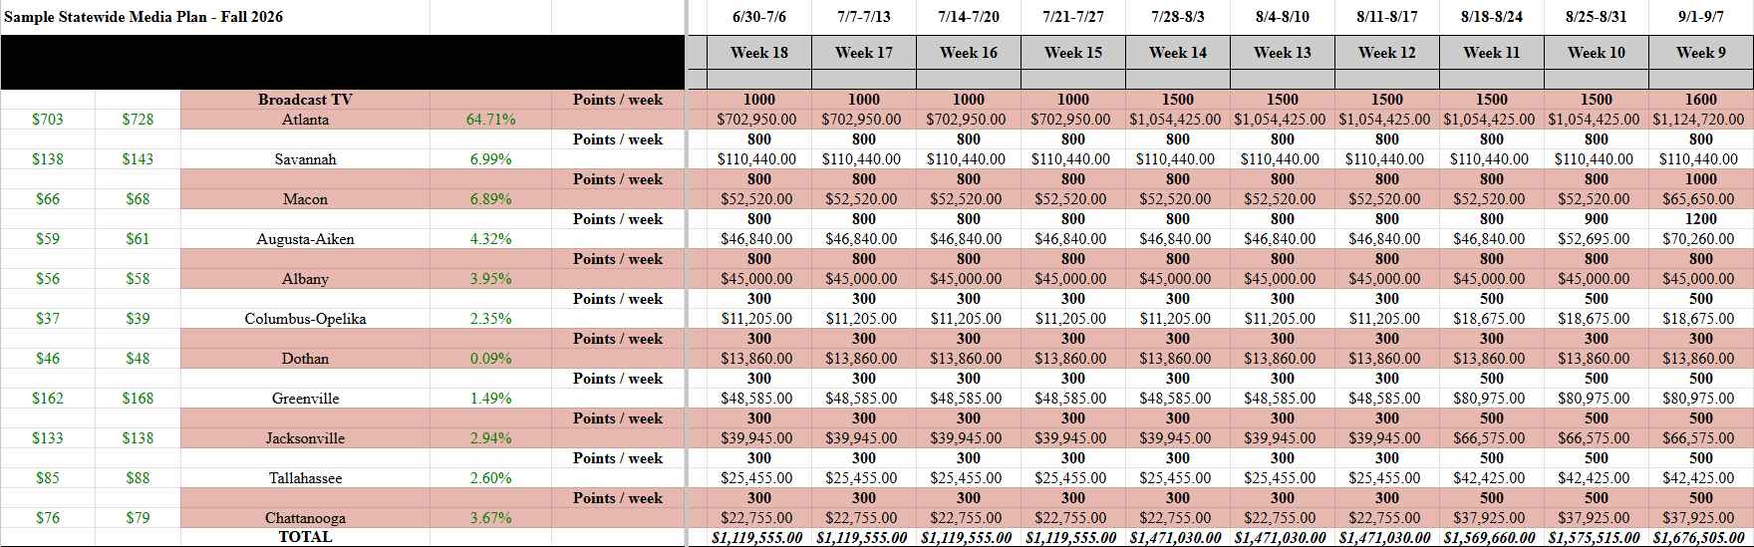
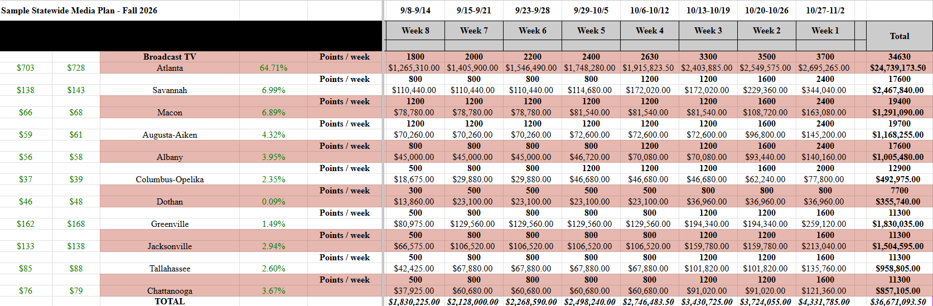

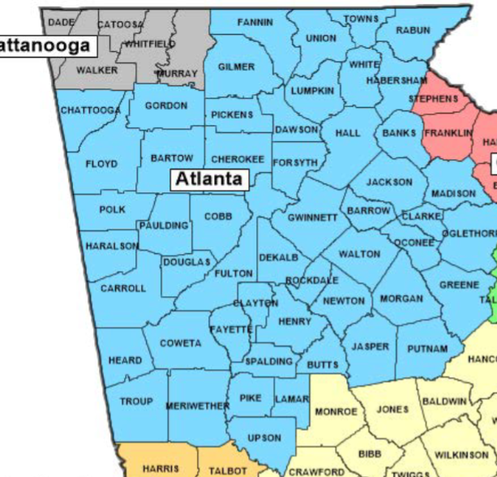
Atlanta Media Market
Although the Atlanta metro area is a significant Democratic stronghold, the media market includes a majority of voters in the state. Approximately half of Collins’ current congressional district falls within the Atlanta media market, so mobilizing Republican voters in those counties will be a key strategic consideration. As such, we must invest considerable resources in reaching the persuadable voters in the suburban to rural counties along the southeast portion of the market with positive messaging. Additionally, we will deliver negative Ossoff messaging within this area as an opponent retargeting tactic to demobilize Black voters who turned out for Warnock in the last election, but are less energized by Ossoff as a candidate. We will increase the frequency of our advertisements beginning late-July until election day. This crescendo of message frequency will ensure in the final weeks leading up to the election our messaging is reaching enough voters enough times.

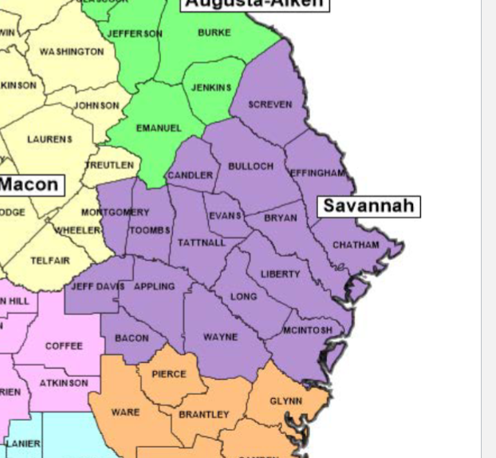
Savannah Media Market
The Savannah media market accounts for approximately 7 percent of our target vote in the state. The frequency distribution for this market will follow a steady progression throughout July and August, but will increase in frequency starting in October and continuously getting higher in the weeks leading up to the election. The suburbs of Savannah will include both voters we intend to persuade and some of our base that needs to be mobilized, which is why we invested in a higher frequency earlier in this market.

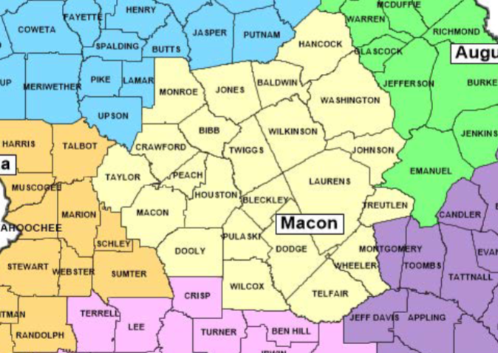
Macon Media Market
The Macon media market also accounts for approximately 7 percent of our target vote. However, since the area is considerably more rural that the Savannah market discussed above, the voters in the Macon market will need to be mobilized rather than persuaded. The northeastern portion of the Macon media market also contains a portion of Collins’ congressional district. With these considerations in mind, the amount of points per week will be lower than other densely populated media markets.

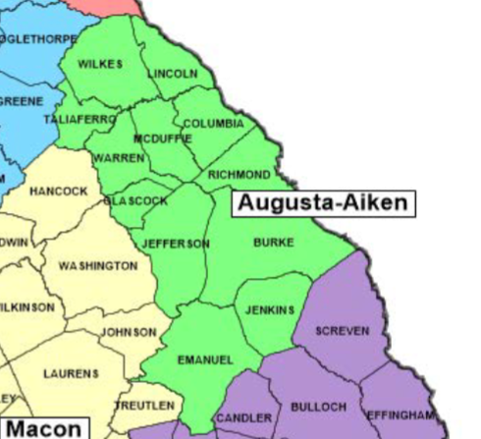
Augusta-Aiken Media Market
The Augusta-Aiken media market includes just over 4 percent of our target vote. We will invest in this market similarly to Macon, with steady frequency through July. Investment will increase incrementally starting in late-August, with the greatest investment in the final two weeks before the election to guarantee message saliency.

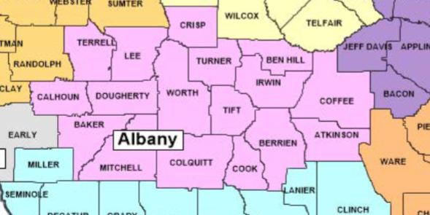
Albany Media Market
The Albany media market is another area with approximately 4 percent of our target voters. The market is relatively rural, so strategy in this market will focus more on mobilization than persuasion. Accordingly, we will maintain consistent investment in this media market throughout the summer, and wait until October to ramp up frequency.
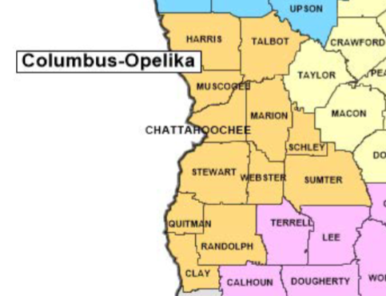
Columbus-Opelika Media Market
The Columbus-Opelika media market contains just over 2 percent of our target voters and part of this media market spreads into Alabama, so our investment will be relatively low to avoid wasting money on Alabama residents. Frequency will increase incrementally in mid-August, mid-September, early-October, and peak in the final two weeks of the election cycle.

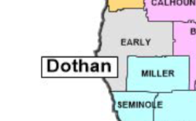
Dothan Media Market
We plan to invest very little into the Dothan media market because it accounts for not even one percent of targeted voters in the state. Since most of the media market actually falls in Alabama and we cannot control which specific counties view our advertisements, any viewer in the Dothan media market that does not live in Georgia directly correlates to a waste of resources. While we will not neglect the media market completely, our investment will remain very low.

Greenville Media Market
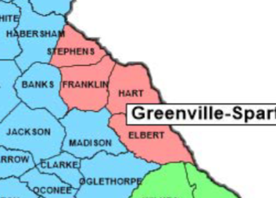
The Greenville media market includes around one and a half percent of our target voters and the market is relatively quite small compared to the rest of the state. The combination of these factors leads us to invest much less compared to larger markets in the state. However, compared to the de minimis amount of voters in the Dothan media market, this market does require higher message saliency. To account for this consideration, we will increase investment incrementally in mid-August, mid-September, mid-October, and in the final week before the election.
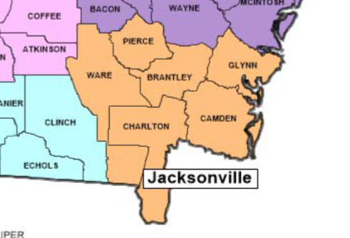
Jacksonville Media Market
The Jacksonville media market accounts for almost 3 percent of our target voter population, but a significant portion of this market is in Florida. To avoid spending money on the Florida population that cannot vote in the election, investment in this market will remain low from July through mid-September. Only in the final three weeks before the election will we increase our frequency to reach voters in this market without spending excess money on audiences who cannot vote in Georgia.

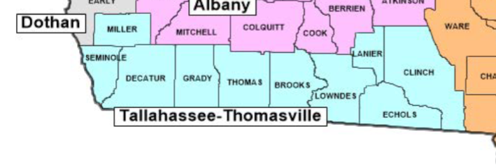
Tallahassee Media Market
The Tallahassee media market is located in the southwest corner of the state and accounts for 2.6 percent of the target vote for the Collins campaign. The Tallahassee media market is based in Florida and as a result, our advertising reach will be split between viewers in the media market who live in Georgia and outside of Georgia. Despite not being as expensive as the Atlanta media market, the Tallahassee media market is still relatively expensive to advertise in because Tallahassee is a relative population center which becomes a factor to consider. Despite the proximity to Tallahassee, much of Southwestern Georgia is relatively rural which means that the Collins campaign will focus on mobilizing voters in these regions to vote. Many of the voters in this region already support the Republican candidate, but may not turnout to vote unless mobilized effectively. This will be achieved through field strategy rather than emphasis on paid media.

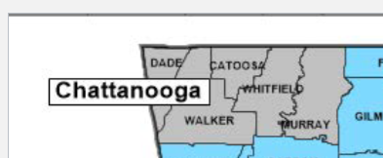
Chattanooga Media Market
The Chattanooga media market is located in the northwest corner of the state and accounts for 3.67 percent of our target voters. The Chattanooga media market is based in Tennessee and as a result, our advertising reach will be split between viewers in the media market who live in Georgia and outside of Georgia. Our desire would be to only reach audiences inside of Georgia, as any viewer outside of Georgia constitutes a waste of resources for the campaign. As a result, our investment in this media market will follow the same general principle as the other media markets in the state, increasing frequency by points per week as Election day approaches, but the dollar-spend in this media market will be lower as it comprises of a smaller percentage of the vote and has the potential to not reach our targeted voters as efficiently as other forms of advertising like digital media advertising.
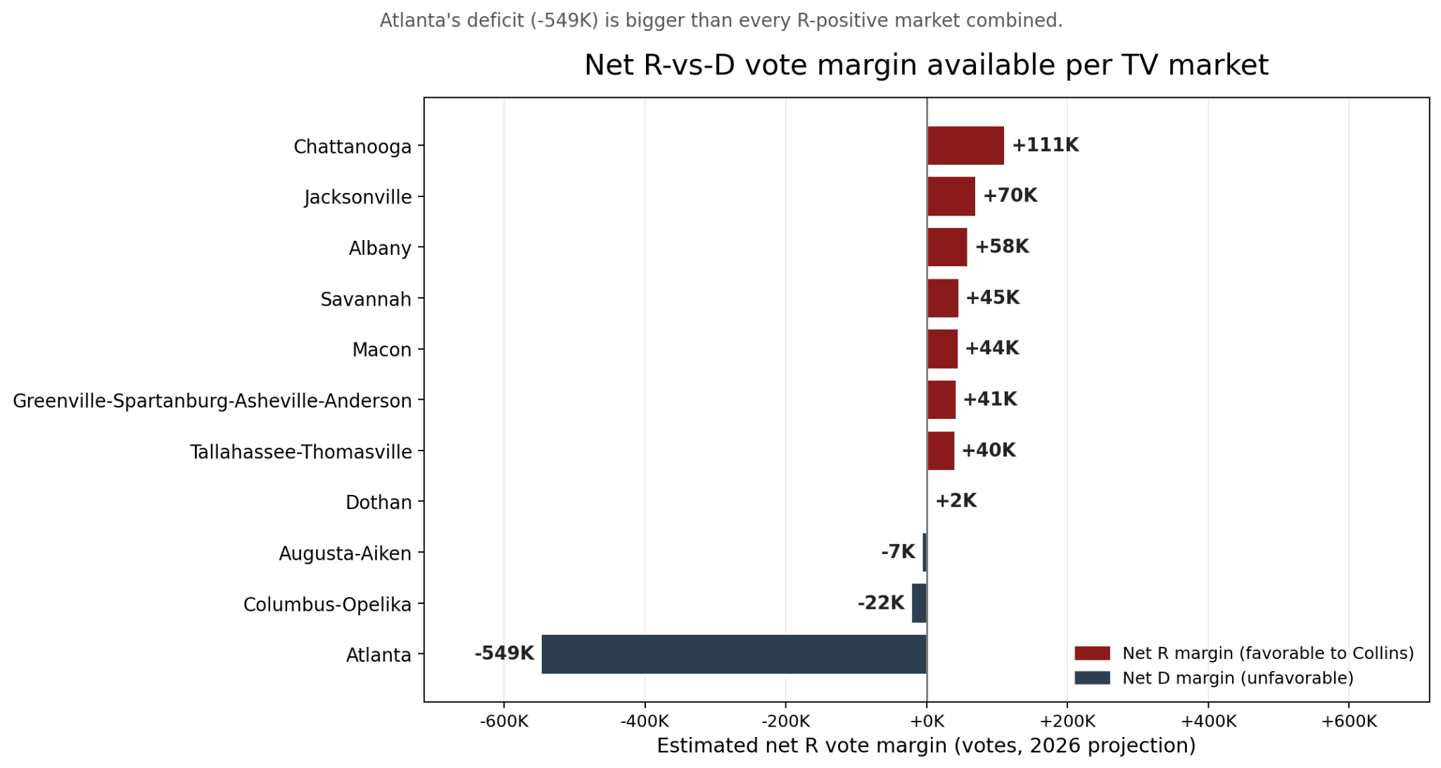
Cable Timeline
The cable timeline will exactly mimic the broadcast timeline.
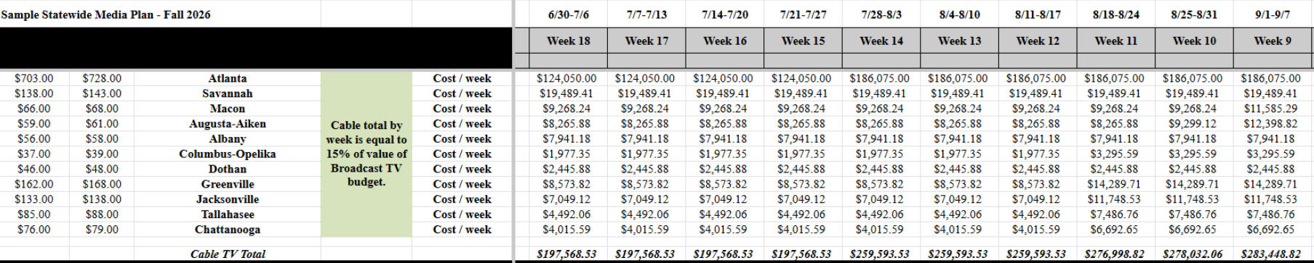
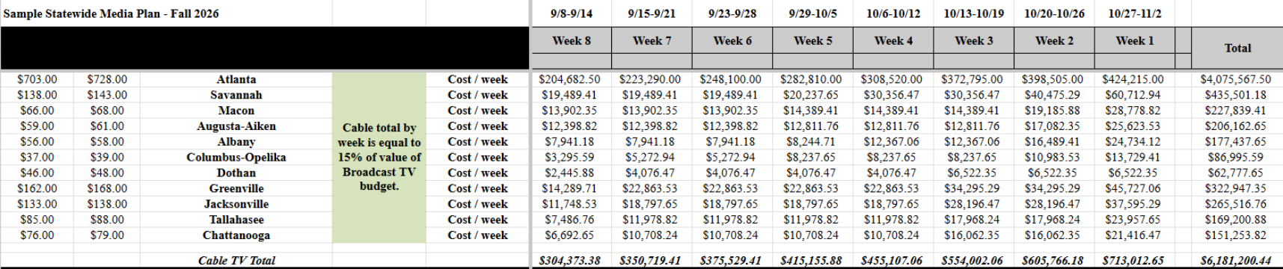
Sample Advertisement Copy:
30 Second Multi-Audience Ad Copy
Hey y’all. My name is Mike Collins. I was born and raised right here in Jackson, Georgia. I grew up driving through this great state as part of my family’s trucking business, and I’ve had the privilege of representing the fine people of the 10th district in Congress since 2022. Now, I’m running for Senate and I’m relying on the support of Georgians like you. As a senator, I’ll make sure that you experience that fine Georgian hospitality that I was raised on. I’m Mike Collins, and I’m always deliverin’ for Georgia.
Voiceover: Paid for by Collins for Georgia

30 Second Attack Ad Copy
Collins Voiceover:
Ossoff promised he would be different. But now he is just another Washington politician.
While Georgia families are struggling to put food on their table, Ossoff has been taking money from out-of-state donors in Woke states like California and New York. He works for them now, not you. He talks about his bipartisanship, but votes with Democrats 99% percent of the time, supporting policies that raise the cost of living and open up our borders. Who is he fighting for, really?
This November, remember you have someone on your side to fight against these career politicians.
I’m Mike Collins, and I’m always on your side. And we will fight together and deliver you the Georgia that you deserve.
Voiceover: Paid for by Collins for Georgia

Radio
Timeline
Following message testing done through polling in May and a focus group in June, we will begin our radio advertising in the first week of July. The allocation of radio by market will differ greatly by radio market and also from the strategy used for TV advertising. The frequency of radio advertising is designed to increase dramatically as election day approaches in order to increase message burn-in within the electorate. The advertising allocations by radio market are based on a calculated blended Cost Per Point (CPP) approach that optimizes for when the messaging will have the greatest reach to the audiences.

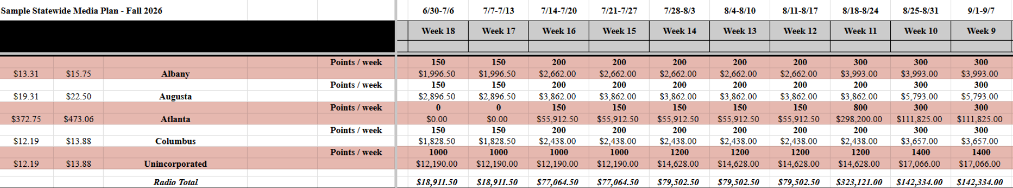
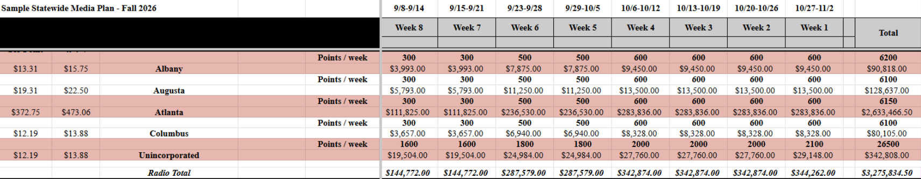
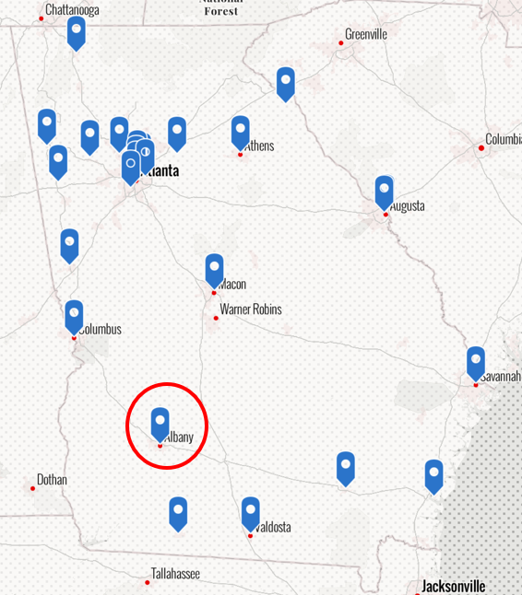
Albany Radio Market
The Albany radio market is in the southwest of the state and caters to a rural area of the state that will be largely supportive of Mike Collins’ messaging. The rates to market to the Albany market based on the blended CPP are much lower than marketing to Atlanta, but are comparable to other semi-urban/rural areas of the state. As a result, the main strategy in advertising to the Albany market will be to mobilize voters that are already likely to vote for Mike Collins.

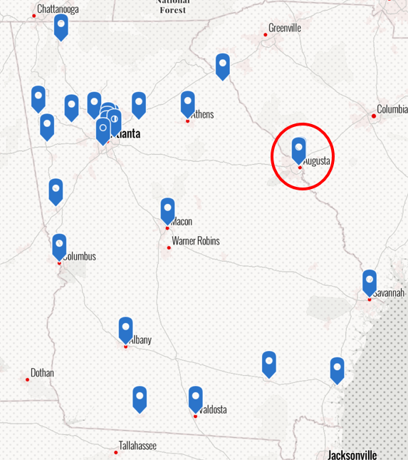
Augusta Radio Market
The Augusta radio market is located on the border of Georgia and South Carolina. It is also a semi-urban/rural market that we expect will have voters sympathetic to the Collins campaign. Our messaging in the Augusta radio market will also aim to mobilize voters, as our strategy partially relies on mobilizing Republican voters who may otherwise not vote. The messaging in the Augusta radio market will likely focus on Collins’ record in the House and his achievements for the state, while a minority of the advertising in this market will focus on attack ads against Jon Ossoff.

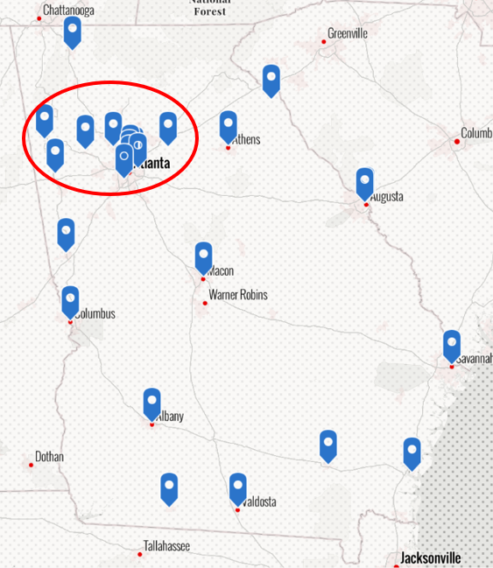
Atlanta Radio Market
The Atlanta radio market is the largest in the state and the most expensive to advertise in. As a result, our advertising in this market will start in the third week in July as opposed to the first week in July like in the other radio markets of the state. The Atlanta radio market consists of the city of Atlanta in addition to the suburban areas surrounding Atlanta. While our focus will be on bolstering our suburban vote in this radio market, it will be difficult to target only the voters sympathetic to our messaging using radio in Atlanta. As a result, much of the messaging in Atlanta will focus on demobilizing our opposition voters and will include attack advertising against Jon Ossoff. Georgia’s 10th congressional district is located just to the east of Atlanta, consisting of some of Atlanta’s Eastern suburbs. Here, Mike Collins is a known quantity, as he has represented this district since 2022. As a result, the advertising will also include mentions of Collins’ work in Congress for Georgians and his key legislation to support Georgians. As the Atlanta radio market also has significant population density compared to other radio markets and regions in Georgia, advertising in the Atlanta market, while more expensive, will allow for greater message reach within the market and may be more effective in persuading and mobilizing voters.

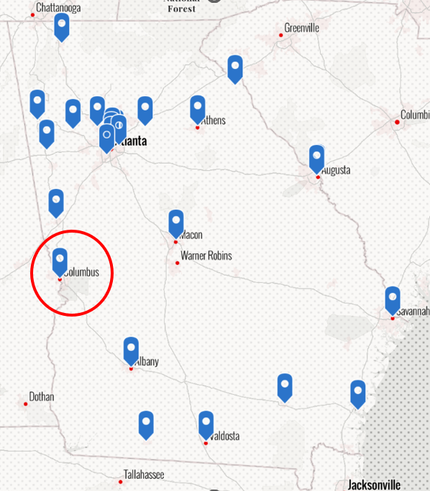
Columbus Radio Market
The Columbus radio market is on the border of Georgia and Alabama. It also represents a mostly semi-urban/rural region of the state. We anticipate that much of the voters in this radio market will be sympathetic to our campaign. As a result, and similar to the other semi-urban/rural regions of the state discussed above, much of the focus with the voters in this region will be to mobilize them to vote in the election rather than persuading them to vote for Mike Collins. A lot of the advertising in this region will be positive advertising about Mike Collins with focus on his record and achievements for Georgians.

Unincorporated Radio Markets
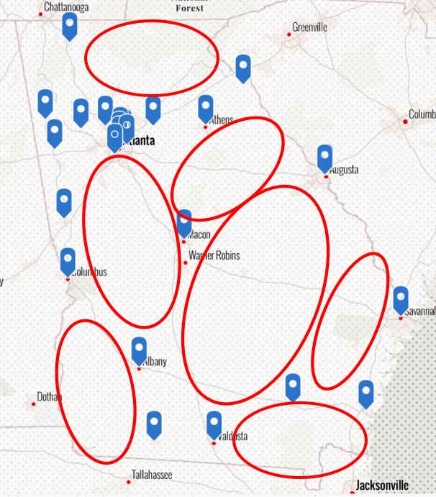
There are a lot of radio markets in Georgia that are not officially surveyed, and as a result, data about these markets is difficult to come by. The regions in red shown to the left make up some of the markets, often rural areas, where we intend to spend significant resources in mobilizing voters. Since data on the CPP is unavailable for these regions, the blended CPP for these unincorporated regions was based on the CPP for cheaper similar markets like Columbus. The resource allocation for unincorporated radio seems unreasonably high upon first glance, but is justifiable because the “unincorporated” section doesn’t refer to just one market like it does in the other rows of the calculation. It refers to multiple markets where the points per week will be divided further. This will result in a more reasonable distribution of points across each of the markets individually. Since these regions are mostly rural, we likely cannot do voter outreach efficiently in other forms, so much of our outreach strategy in these areas will rely on radio messaging. Most of our messaging will be positive about the Collins campaign and will emphasize the need to vote thereby increasing the mobilization effort that is the main priority for the Collins campaign across the state.
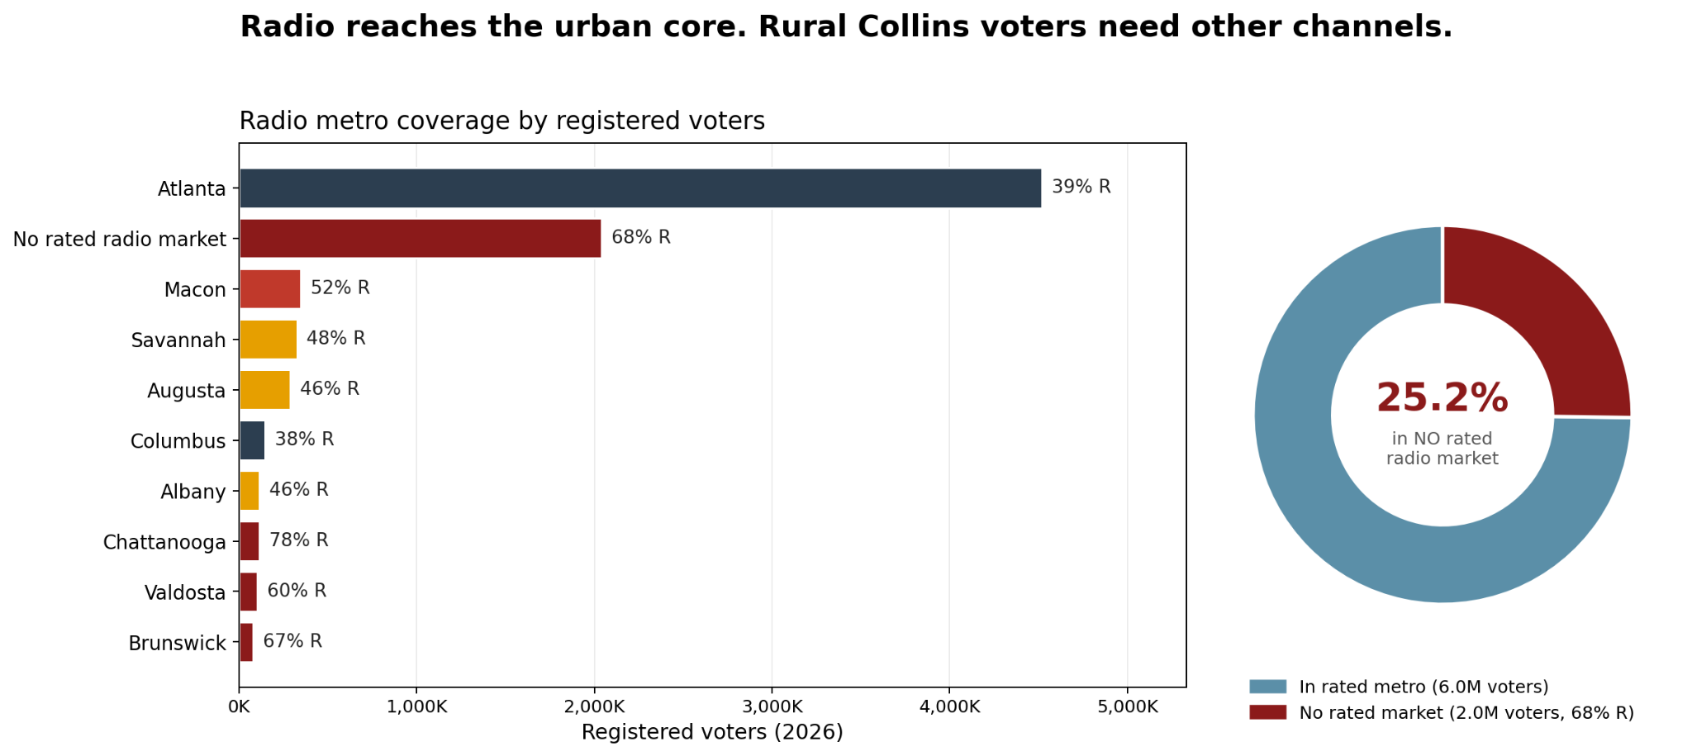

Digital Media
Timeline
The timeline for digital advertisements will closely follow the TV and Radio rollout timelines. This will ensure message coordination across media modes and platforms of communication. This also allows the messages created for digital communications to be tested with audiences in our May polling and June focus group. However, search advertisements will not be heavily invested into until much closer to the early voting window of the election.

CTV
Budget | Target Audience | Impressions | CPM | Frequency | Reach | TRP
$5,616,000 | 500,000 | 129,025,000 | $40 | 180 over 18 weeks  10 per Week Average | 716,806 | 28,080 Total TRP  1,080 Average TRP/Week

Platforms in the CTV subsection of digital media appeal to a broader audience. Many of these streaming service platforms have a higher barrier of entry for audiences due to their subscription fee model, so our target audience was lowered to account for the smaller portion of the population with access to CTV platforms.

OTV
Budget | Target Audience | Impressions | CPM | Frequency | Reach | TRP
$4,914,000 | 750,000 | 196,560,000 | $25 | 180 over 18 weeks  10 per Week Average | 1,092,000 | 26,621.86 Total TRP  1,023.9 Average TRP/Week
TV
The distribution of platforms within the OTV section will heavily favor YouTube, which will account for 60% of advertising space or 614.34 of the 1023.9 TRP average per week. Youtube is used by a majority of Americans aged 50 or over who are more likely to vote for Republican candidates. It is also used by over 90% of Generation Z, allowing us to reach young men who are leaning towards towards the Republican Party. YouTube also has a lower barrier to entry compared to CTV as there is no subscription fee, so has an audience that may not use CTV.

Social Media
Budget | Target Audience | Impressions | CPM | Frequency | Reach | TRP
$2,106,000 | 750,000 | 140,400,000 | $15 | 180 over 18 weeks  10 per Week Average | 780,000 | 18,720 Total TRP  720 Average TRP/Week

Our target audience for social media is relatively high because we are reaching out to two different groups. We are targeting older generations through Facebook as approximately 60% of men and women aged 50 or over regularly use Facebook and many of the people we are targeting to persuade and mobilize will use it so Facebook will make up the majority of social media spend. We are also targeting younger men who consume digital content on platforms such as Reddit, Instagram, and X and are increasingly voting for Republican candidates.

Audio
Budget | Target Audience | Impressions | CPM | Frequency | Reach | TRP
$1,333,800 | 350,000 | 133,380,000 | $10 | 180 over 18 weeks  10 per Week Average | 74,000 | 38,108.5 Total TRP  1465.7 Average TRP/Week

We have a lower target audience for audio digital advertisements because we invested heavily in radio advertisements which have an older and more working class audience that better aligns with our target voters. We will aim to persuade and mobilize a smaller audience of young men with digital audio, who are likely to listen to podcasts through platforms such as Spotify.

Search
Budget | Target Audience | Impressions | CPM | Frequency | Reach | TRP
$70,200 | 200,000 | 46,800,000 | $1.5 | 100 over 18 weeks  5.56 per Week Average | 468,000 | 23,400 Total TRP  900 Average TRP/Week

Google Search Ads are relatively cheap to implement and have broad reach, as Google is the default search engine for almost all demographics. We wanted to ensure that the search ads would appear closest to the election because the general electorate will probably not consider the election, the candidates, or the impacts until when early voting begins and the weeks immediately preceding election day. As a result, a majority of our budget and total TRP for Google Search Ads is concentrated in October and November in the immediate lead-up to Election Day. October 13th through 30th is the Early Voting window so we have allocated the highest concentration of TRP within that window to reach voters researching candidates during that time. Our search results will connect to our campaign page that speaks to Mike Collins’ achievements and focuses. Additionally, we may in the final stretch of the campaign, aim to launch attack ads through links displayed in searches associated with Jon Ossoff and his campaign.

TRP Timeline
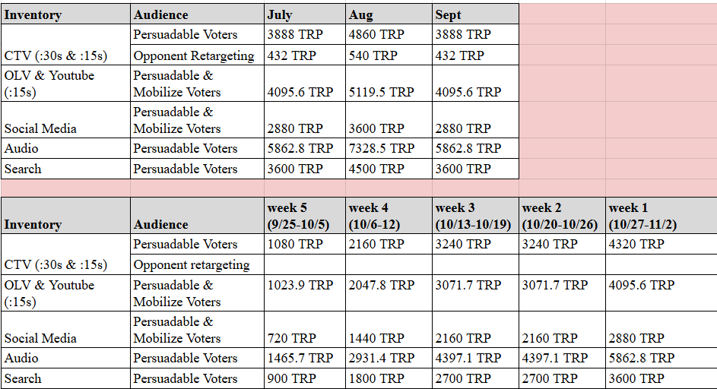

Targeting and Content
Digital advertising will follow similar targeting to broadcast and radio, however the ads will be set to show to voters in specific ZIP codes within our identified target counties for persuasion and mobilization. We will also set advertising to specific demographics, such as gender and age, to allow
a more accurate degree of targeting and differentiation in ads tailored to different audiences.

Persuadable ads will be set to the counties identified as having the highest persuadable voter opportunity, including Paulding, Houston, Columbia, and Lowndes counties. Persuadable ads will begin in July, building name recognition and favourability for Mike Collins and increasing in frequency as the election draws closer. Persuadable ads will feature content that addresses affordability and job availability, including highlighting Collins’ background as a business owner and employer, as these are issues of biggest concern to persuadable Georgia voters.

Mobilization ads will be set to areas identified as having large Republican support that needs to be mobilized to turn out to vote and doesn’t require much persuasion to vote for the Republican candidate. These counties include Hall, Bartow, and Carroll counties. Mobilization ads will begin in September and increase significantly in October as early voting begins. Mobilization ads will focus on introducing Collins as a person including his connections to Georgia and background as a rural business owner, as the mobilization Republican demographic needs less convincing based on policy platform and more need to be informed who Collins is and that he is standing against the Democrat incumbent.

Our core persuasion target demographics are suburban white women who sometimes or always vote, in particular those aged 55 or over as these women are more likely to vote for Republicans in general. Persuasion ads should be targeted to this demographic with a primary focus on affordability and public safety, which could include anti-immigration stances, as these issues have been identified as the most important to female voters in Georgia. To appeal to women the ad imagery could include Collins’ wife, children, and grandchildren, which is more likely to resonate with women.
Another persuasion target demographic for us is young men, who are leaning more Republican and are particularly focused on economic issues including housing affordability and employment opportunities. Ads targeted to these men should emphasize Collins’ platform of bringing jobs to Georgia, being an employer (primarily of men as truck drivers), and bringing down housing prices by reducing immigration.

Our core demographic to mobilize to get out to vote is white male Republican voters who sometimes vote, especially those older and those living rurally. Mobilization ads should be targeted to this demographic and feature heavily on Collins’ blue collar background and that he is challenging the Democrat incumbent for Senate. Collins’ male truck driver staff, rural background, and firearm ownership could be included to demonstrate relatability to the older male target demographic.

We will have minimal ads running in Democrat leaning counties and to demographics that are not our targets, such as voters in inner urban Atlanta. However, we will run some negative ads on Ossoff to these voters to demobilize them to not turn out to vote, especially older black residents who sometimes vote and are a core target demographic for Ossoff. These voters may be more susceptible to not turning out to vote due to the lack of Black candidates on the ballot and lack of prominent Black surrogates mobilizing them. The content of these ads may center on Ossoff voting for the Fiscal Responsibility Act in 2023, which removed entitlement to SNAP benefits for people aged 49-54 who do not meet their work requirements. This issue may resonate with older Black voters in Atlanta who are more likely to care about access to SNAP compared to other voters and therefore be less motivated to vote for Ossoff. These ads will air from July through to September.
PACs & Independent Expenditures
We anticipate that PACs and Independent Expenditures will be airing their own TV, Radio, and Digital advertisements throughout the campaign cycle. Due to federal campaign restrictions, we cannot determine the frequency or impact of their advertisements.

6 Second Ad Copy
Hey y’all. My name is Mike Collins, and I’m running for Georgia Senate.
Voiceover: Mike Collins - Always deliverin’ for Georgia

15 Second Ad Copy
Georgia, my name is Mike Collins and I’m running for Senate. I’m a small business owner and I know what it’s like to work hard and try to make ends meet. In the Senate, I’ll work to support Georgians keeping more of their money in their pockets. I’m Mike Collins, and I’m always deliverin’ for Georgia.

Static ad copy
Mike Collins for Senate
Delivering for Georgia
YES to affordability for families
YES to creating jobs for Georgia
YES to keeping Georgia safe

Owned digital
In addition to paid digital advertising the Collins campaign will continue to operate Collins’ own campaign social media accounts. He will post organic content on Facebook, where more of our base supporters are active, to keep them engaged and encourage them to turn out to vote. Content will include similar messaging and imagery as paid digital advertising, with the addition of photos and videos from the campaign showing Collins engaging with voters in a variety of settings for an authentic image of the candidate.

While the focus will be on Facebook, Collins will also post to X, which can include stronger messaging as the audience of X expects that, as well as Instagram which will cater more towards the white suburban female persuadable audience with messaging and imagery that appeals to them. Collins should also start using LinkedIn, especially posting about economic issues and job availability which will appeal to younger men concerned about jobs and the economy.

Collins has an existing campaign website which he will continue to use, with content about his bio, endorsements, media content, etc. Press releases will be posted to the website.

Earned Media
January
- Small Business tour in Athens

February
- Anniversary of Laken Riley’s murder
- Visit Memorial Meadows Hospital in Vidilia, GA

March
- Visit Mack Trucks inc factory on March 10th
- Monthly Town Hall
- Small Business tour in Carroll County
- Small Business tour in Cherokee County
April
- Monthly Town Hall
- Small Business tour in Lowndes County
- Small Business tour in Bibb County
May
- Visit the National Museum of the Mighty Eighth Air Force (Memorial Day exhibition)
- Attend Acworth Memorial Day Ceremony
- Attend Marietta Memorial Day
- Voices and Votes: Democracy
- Visit Camp Frank D. Merrill
- Monthly Town Hall
- Small Business tour in Chatham County
- Small Business tour in Muscogee County
June
- Visit and Tour Jaemor Farms
- Monthly Town Hall
- Small Business tour in Richmond County

July
- Old timers July 4th Parade
- Visit Fort Gordon Military base
- Press conference
August
- Monthly Town Hall
- Visit the Cobb County police station
- Visit Camp Frank
September
- Monthly Town Hall
- Speak at Georgia’s Trucking Association
October
- Visit Rocky Ridge trucks factory in Franklin Springs, Georgia
- Monthly Town Hall
November
- Election Night Nov 3

The goal of these events is to reinforce Mike Collins as a hands-on conservative focused on economic growth, public safety, and direct voter engagement. Through small business tours, monthly town halls, and visits to companies like Mack Trucks and Rocky Ridge Trucks, the campaign highlights Collins’ support for local businesses, working families, and Georgia’s trucking industry. Stops at places such as Jaemor Farms and Memorial Meadows Hospital allow Collins to discuss inflation and community concerns directly with voters. Events tied to patriotism, law enforcement, and national security, including the Laken Riley anniversary remembrance, military site visits, Memorial Day events, and local police engagements, are designed to present Collins as a strong advocate for Georgia families, veterans, and public safety. We aim to show that Mike Collins is delivering for Georgia by remaining visible, accessible, and connected to communities across the state, leading up to Election Day.

Political Mail

Direct Mail Program Overview
The first part of this mailing plan outlines a sample strategic outline of the direct mailing program for the month of September, solely focusing on two targeting groups and thus reflecting the broader strategy of the political mailing process. Every single item uses a consistent 6x11 format and a fixed cost rate of $0.47 per individual mailer, covering production, budgeting and uniformity across segmented audiences. The sample program outlines two sequential waves, where each demographic group receives three repeated exposures over a short window of one week.

The second part of this strategic plan provides a more comprehensive and holistic view of the overall strategy, budgetary expenditures and strategic targeting, with the explicit aim of winning with a 52% majority. The explicit objective in segmenting both parts is differentiating between the sample chart at the end of the campaign plan and the overall targeted strategy that will guide the framework of the political mailing plan.

Sample Audience Strategy
The program is divided into two specific segments:
- Rural White Men (35+) – This program focuses on mobilization, engagement and repeated exposure for members of the campaign’s base.
- Suburban White Women (55+) – The second wave reflects a bigger geographic concentration focusing on the suburbs of Atlanta. The recipients of this wave constitute a persuadable faction of the overall electoral strategy.
This sample audience segmentation allows for showcasing our strategic delivery of direct mail, ensuring each segmented group receives various impressions in the target period and with a detailed purpose.

Sample Delivery Schedule & Volume

Sample Phase 1: Rural Outreach
- Dates: September 11, 13, and 15
- Audience: Rural White Men (35+)
- Volume per drop: 150,000 pieces
- Total volume: 450,000 pieces
- Cost per drop: $70,500
- Total phase cost: $211,500
This phase is designed to promote base mobilization, while reinforcing candidate visibility.

Sample Phase 2: Suburban Outreach
- Dates: September 21, 23, and 25
- Audience: Suburban White Women (55+)
- Geography: Cobb County, Gwinnett County, and DeKalb County
- Volume per drop: 150,000 pieces
- Total volume: 450,000 pieces
- Cost per drop: $70,500
- Total phase cost: $211,500
This phase targets a bigger geographic and demographic composition focused on the suburbs of Atlanta, including three major counties with high levels of concentration.

Sample Budget Summary
- Total mail drops: 6
- Total pieces mailed: 900,000
- Total program cost: $423,000
- Unit cost: $0.47 per piece (fixed across all placements)

General Audience Strategy for Direct Mail

Group 1: Rural White Men (35+)
- Volumes: 150,000 / 150,000 / 150,000
- Total Volume: 450,000
- Total Cost: $211,500
Rationale:
Mobilizing the political base and reinforcing conservative values.

Group 2: Rural White Men (18–34)
- Volumes: 150,000 / 150,000 / 150,000
- Total Volume: 450,000
- Total Cost: $211,500
Rationale:
Younger rural voters targeted to reinforce base support across age groups.

Group 3: Rural White Women (35+)
- Volumes: 150,000 / 150,000 / 150,000
- Total Volume: 450,000
- Total Cost: $211,500
Rationale:
Strengthening rural support across gender lines.

Group 4: Hispanic Voters
- Volumes: 150,000 / 150,000 / 150,000
- Total Volume: 450,000
- Total Cost: $211,500
Rationale:
Tapping into the 2024 groundswell of GOP support amongst Hispanic voters, specifically Hispanic men.

Group 5: Younger Suburban White Men (18-34) (Atlanta Media Market)
- Volumes: 150,000 / 150,000 / 150,000
- Total Volume: 450,000
- Total Cost: $211,500
Rationale:
Male voters in the suburbs of Atlanta may swing Republican and will influence high voter turnout.

Group 6: Suburban White Women (35–54) (Atlanta Media Market)
- Volumes: 150,000 / 150,000 / 150,000
- Total Volume: 450,000
- Total Cost: $211,500
Rationale:
Suburban white women and moms drive voter turnout and are part of a demographic that may be responsive to certain conservative-leaning issues, including Make America Healthy Again.

Group 7: Suburban White Women (55+) (Atlanta Media Market)
- Volumes: 150,000 / 150,000 / 150,000
- Total Volume: 450,000
- Total Cost: $211,500
Rationale:
Older women have a high propensity to engage with direct mail.

Group 8: Young Black men (18-34) (Atlanta suburbs)
- Volumes: 150,000 / 150,000 / 150,000
- Total Volume: 450,000
- Total Cost: $211,500
Rationale:
This targeted group represents a highly persuadable group concentrated in key Atlanta-area counties.

Overall Direct Mail Program Summary
- Total Mail Drops Throughout Campaign: 24
- Total Budget for the Direct Mail Program: $5,076,000
- Unit Cost: $0.47 per piece
- Time Window for Mail Delivery: June-October

Direct Mail - Program Summary
The sample program showcased throughout the first part of this mailing plan entails a one-month sequenced strategy that aims to explain the chart in this campaign plan. This sample wave of the program targets rural male audiences with a focus on mobilizing the political base, and maximizing candidate exposure, as well as suburban Atlanta, focusing on female audiences and densely populated counties like Cobb, Gwinnett, and DeKalb to increase message penetration and strengthen persuasive efforts. Put together, this sample program balances repeated exposure, demographic targeting, and geographic differences to ensure effective direct mail targeting, while maintaining consistent and cost-effective expenditure.

The overall mailing strategy segments the most important audiences and an equal volume distribution of mail. Rural audiences are prioritized to mobilize the political base, while suburban audiences are sequenced to penetrate key persuadable groups in Atlanta-area counties. Overall, the political mailing plan aims to maintain consistency in exposure, strategic audience targeting, and cohesive and statewide coverage. The total budget for the persuasion mailing program is $5,076,000, and will last from the beginning of June to the end of October in the leadup to election day. The budget allows for 24 total mailing campaigns with a flight of three mailers per targeted individual. Each campaign will focus on a demographic group including the groups mentioned above and more. Some campaigns will utilize positive messaging to the base and persuadable voters while some will feature attack ads against Ossoff, especially in Metro-Atlanta.
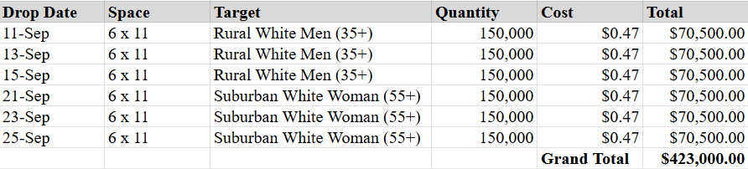
Sample of Persuasion Mailing Plan: 2 Audience Example

Mail & Print Budget
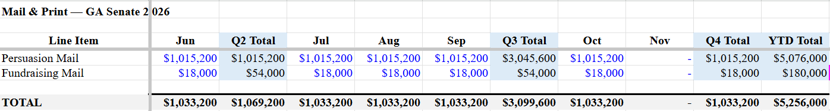

Field Plan
Field Plan Summary
This field plan outlines a strategic operation for field office placement and organizing efforts for Mike Collin’s U.S. Senate campaign in the state of Georgia to target specific counties crucial to the objective of reaching 52% of the expected vote. The main goal is to create a strategic and grass-roots operation that intensifies and strengthens turnout, mobilization and persuasion among base voters, persuadable groups and other targeted communities, ensuring maximum electoral performance across the state. Field operations will aim to reinforce strategic messaging by directly engaging with voters and creating a continuous community presence. As each field office opens, the Field Organizers will train throughout the first month. All offices will open by June to ensure field staff are trained by July, so each office will be fully operational to begin field tactics at the start of July.

Field Staff
Field Director -$15,000/Month
The Field Director will be hired in January with the opening of the Headquarters. The Field Director will organize the campaign's field outreach strategy. They will oversee the creation and management of the field team, volunteer recruitment, Get Out the Vote efforts, and grassroots engagement.
Deputy Field Director - $13,750/Month
The Deputy Field Director will be hired in April as the campaign begins to open more Field Offices as the campaign ramps up.
GOTV Manager-$12,500/Month
The Get Out the Vote Manager will be hired in June, in time for all of the field offices to be fully operational. The Get Out the Vote Manager will work directly with the Field Director and Regional Field Directors to design and implement a statewide GOTV program. They will increase GOTV efforts in target counties crucial to electoral victory.

Data Manager-$12,500/Month
The Data Manager will be hired in June in time for all of the field offices to be fully operational.
Regional Field Directors (7)-$7,500/Month/Employee
The Regional Field Directors will be hired in a staggered manner based on the opening of each field office. There will be seven Regional Field Directors: one in each field office excluding headquarters where the Field Director will manage this role. Their start dates will align with the opening of their respective field office. Each will report to the Field Director and manage their office’s Field Organizers.
Field Organizers (17)-$5,000/Month
The hiring of the field organizers will vary based on the opening of the field offices between January (for the Headquarters) and June. There will be two Field Organizers in each regional office to support voter outreach in their respective regions through field tactics designed by the Field Director.
Volunteer Coordinators (5) -$5,000/Month/Employee
The Volunteer coordinators will be hired as field offices open in each geographic region of the state.
Geographic Placement
Turnout across rural regions and suburban regions is pivotal, particularly in suburban counties which have become more purple in recent years. The campaign will divide the state of Georgia geographically, loosely based on media markets for the purposes of field organizing. There are five total regions. The Atlanta, Chattanooga, and Greenville Media markets will form the “North Georgia” region where the campaign will establish its headquarters in addition to other field offices. Macon's office in Bibb County anchors the “Central Georgia” region, covering 24 counties across the Macon media market with no other office within reach. The Augusta and Savannah media markets will together form the East Georgia Region with two field offices established here. The Tallahassee and Jacksonville media markets will form the “South Georgia” region with one office located in this region. Finally, the Columbus, Albany and Dothan media markets will form the “Southwest Georgia” region with one office opened here.
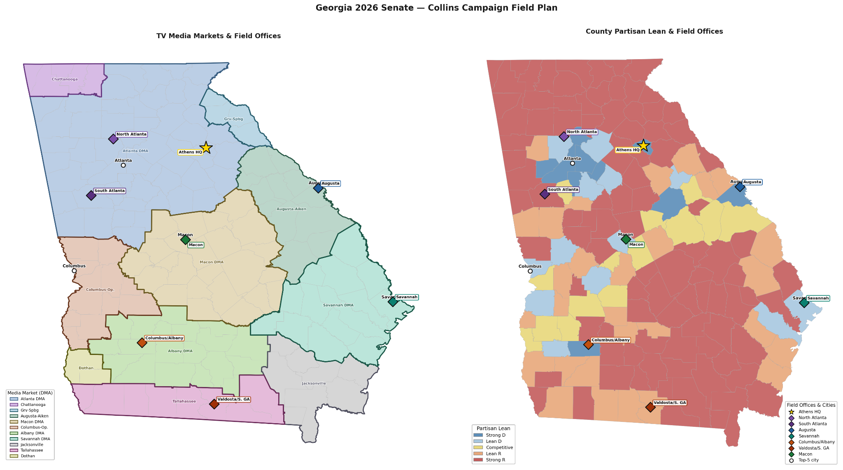

Field Office Expansion Timeline
The opening of these field offices across Georgia will spam from the month of January to the month of June. Office placement will prioritize three key components: voter outreach, message penetration and maximizing efficiency.
- January: North Region Office 1 (HQ) — Athens, Clark County
- March: North Region Office 2 — Carroll County
- March: North Region Office 3 — Cherokee County
- April: South Georgia Office 4 — Lowndes County
- April: Central Georgia Office 5 — Bibbs County
- May: East Region Office 6 — Chatham County
- May: Southwest Region Office 7 — Muscogee County
- June: East Region Office 8 — Richmond County
The North Georgia region will strategically open the way for this field operation focusing on four components: population geography, volunteer prospects, media saturation and persuasion opportunity. The Central and South Georgia locations ensure rural turnout, while the Eastern and Southwest offices will double down on reach opportunities into different economic and cultural areas that are fundamental for electoral margins.

Office Budget Framework:
The field office budgets will vary from that of the headquarters due to size and operating costs. The HQ budget will be higher because of the type of work it will conduct, whereas the other field offices will be lower in prices:
- HQ: $10,000 per month rent + $3,000 operational expenses
- Other Field Offices: $5,000 per month rent + $2,000 operational expenses
This operational budget includes office supplies, technology, voter contact infrastructure, digital devices/tools and field strategic costs.

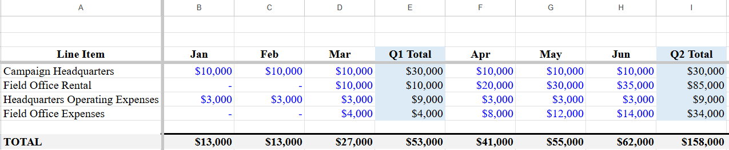

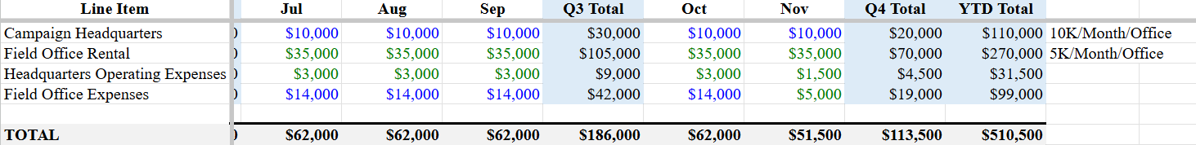

Field Office Geography and Rationale for Placement
The campaign will operate eight field offices positioned to cover the state’s mobilization and persuasion universes across all major media markets. Athens in the North Georgia region serves as the campaign headquarters, anchoring the northeast corridor and placing the campaign within reach of three top-20 priority counties. Two satellite offices in the Atlanta suburbs, one in North Atlanta (Cherokee county) and the second in South Atlanta (Carroll county), divide the metro ring. North Atlanta covers the highest-concentrated persuasion territory in the state and South Atlanta extends the operation into the southwest metro arc. Augusta (Richmond county) covers the coastal market and southeastern Georgia. Columbus/Albany/Dothan consolidates three media markets that share similar mobilization profiles but lack the individual volume to support triple offices, so one office will go in Muscogee county. Valdosta in the South Georgia region, in Lowndes County captures the two highest-ranked counties with no viable coverage from any other office, with a secondary reach down to the Florida border.

The eight-office structure maps directly to the priority rankings and media market geography. Athens HQ will open first in January in Clarke county anchors the northeast corridor within reach of Walton county (#13), Barrow county (#14), and Jackson county (#17), covering 28 counties and a 281,099-voter mobilization universe. North Atlanta in Cherokee county is the highest-ROI placement: Cherokee county (#1), Forsyth county (#2), Hall county (#3), and Paulding county (#4) sit in this territory, which holds the state's largest persuasion concentration at 188,506 Kemp-but-not-Walker voters. South Atlanta’s office in Carroll county covers the southwest metro arc where Houston county (#5), Coweta county (#7), and Carroll county (#9) drive a 847,527-voter mobilization universe across 33 counties. Augusta’s office in Richmond county is justified almost entirely by Columbia County (#6), the sixth-ranked priority county statewide with 113,081 active voters and 5,530 in the persuasion pool. Savannah’s office in Chatham county anchors the coastal market around Bulloch County (#18), Effingham County (#22), and Bryan County (#26). The Southwest Georgia office in Muscogee county consolidates three southwest media markets where neither has enough top-priority volume to warrant standalone infrastructure, with Harris County (#38) and Lee County (#43) as the lead targets. The South Georgia Regional office in Lowndes county exists because Lowndes County(#10) and Glynn County (#16) are the two highest-ranked counties with no plausible coverage from any other office, with Camden County (#24) adding another 39,444 active voters on the Florida border.

# | Office | County | Media market | Region | Opening date | Rationale for rank
1 | Athens Campaign HQ | Clarke County | Atlanta DMA | North GA | Jan | HQ opens first; all other offices depend on it.
2 | South Atlanta Field Office | Carroll County | Atlanta DMA | North GA | March | Highest portfolio priority score; #5, #7, and #9 counties across 17-county footprint.
3 | Valdosta Field Office | Lowndes County | Tallahassee - Thomasville DMA | South GA | March | Lowndes (#10) and Glynn (#16) carry heavy individual scores; no other office covers them.
4 | North Atlanta Field Office | Cherokee County | Atlanta DMA | North GA | April | Anchors #1 and #2 priority counties; highest per-county priority score of any office.
5 | Macon Field Office | Bibb County | Macon DMA | Central GA | April | Central corridor has no other coverage; 22 counties with steady mid-tier priority scores.
6 | Savannah Field Office | Chatham County | Savannah DMA | East GA | May | Chatham is #7 by persuasion universe; the remaining portfolio is lower-ranked coastal counties.
7 | Columbus Field Office | Muscogee County | Columbus - Opelika DMA | Southwest Georgia | May | Large county count but lower-priority portfolio; Harris (#38) and Lee (#43) lead.
8 | Augusta Field Office | Richmond County | Augusta - Aiken DMA | East GA | June | Smallest portfolio at 6 counties; Columbia (#6) is high value but not enough to move the score.

Field Tactics
The Field team will layer voter outreach tactics to ensure voters are reached and mobilized through more than one form of communication. The field operation will be heavily assisted by the Rick Jackson for Governor campaign. Since Jackson is a billionaire, his campaign will be flush with resources. We will use this to our advantage by conjoining our field operations. Since many of our supporters are in rural areas, canvassing will strain resources more than it will our Democratic opponent Ossoff who will canvass in densely populated areas. By conjoining our field operations with the Jackson campaign, we can have canvassers carry both candidates literature and branding materials to use Republican statewide race resources efficiently. We will use phone banking to supplement canvassing in the rural areas of the state especially.

Budget

Total Revenue
We anticipate raising $80,000,000 based on past Republican candidate fundraising performance and the increased national attention on this election. We will spend $8,000,000 in total to raise the sum of $80,000,000, leaving the campaign with $72,000,000 to spend on all campaign expenses.

Revenue Plan

Major Donors - 40% of Total Budget ($32,000,000)
Republican candidates tend to raise more money from major donors, allowing our campaign to assume 40% of our budget will come from major donations. In-state donations will account for a smaller portion of this income, 25%, because there are less major donors in Georgia. National major donors will account for 75% of this income. The primary region will be the West Coast because that is where the most major donors are. The secondary region is the Tri-State area because it is also very donor concentrated. Collins will raise money in the DC Metro area by partnering with other Republican congressmembers to host events. Florida will be a region we receive major donor contributions from because of its close proximity to Georgia and the strong conservative population that lives in the state. Finally, the Texas energy corroder will generate donations because Collins’ committee positions are heavily involved with industries in the area.

Fundraising Costs- $640,000
We are going to raise $8 million in state through breakfasts/coffees, luncheons, receptions/dinners, high value events, larger regional events, and call time. This will cost approximately $160,000. We are going to raise $24 million through national donors focused in four regions, which will cost $480,000 when accounting for travel expenses and other costs involved with hosting events and taking donors out for meals.

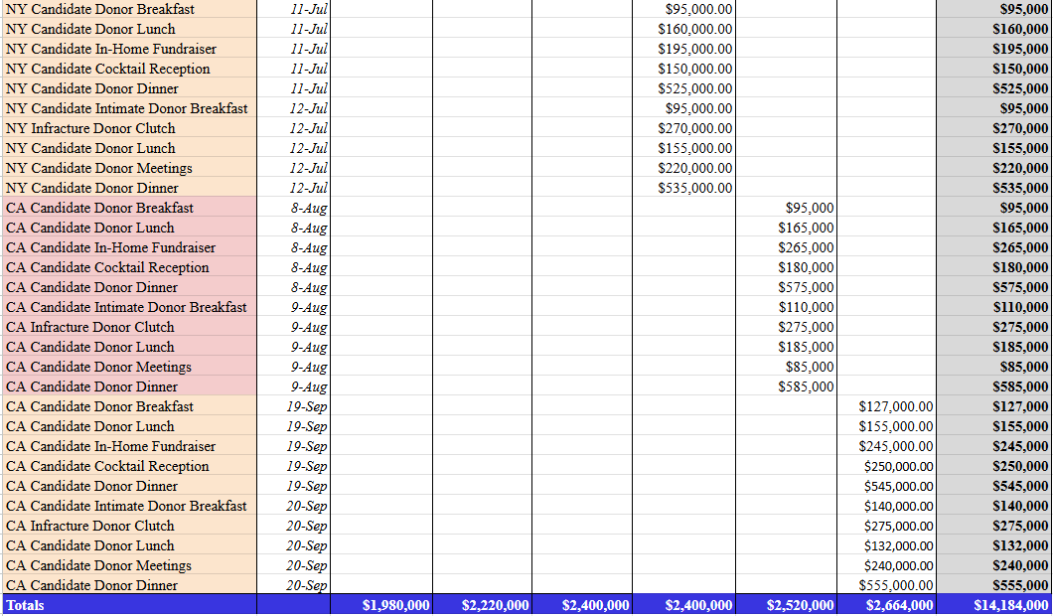
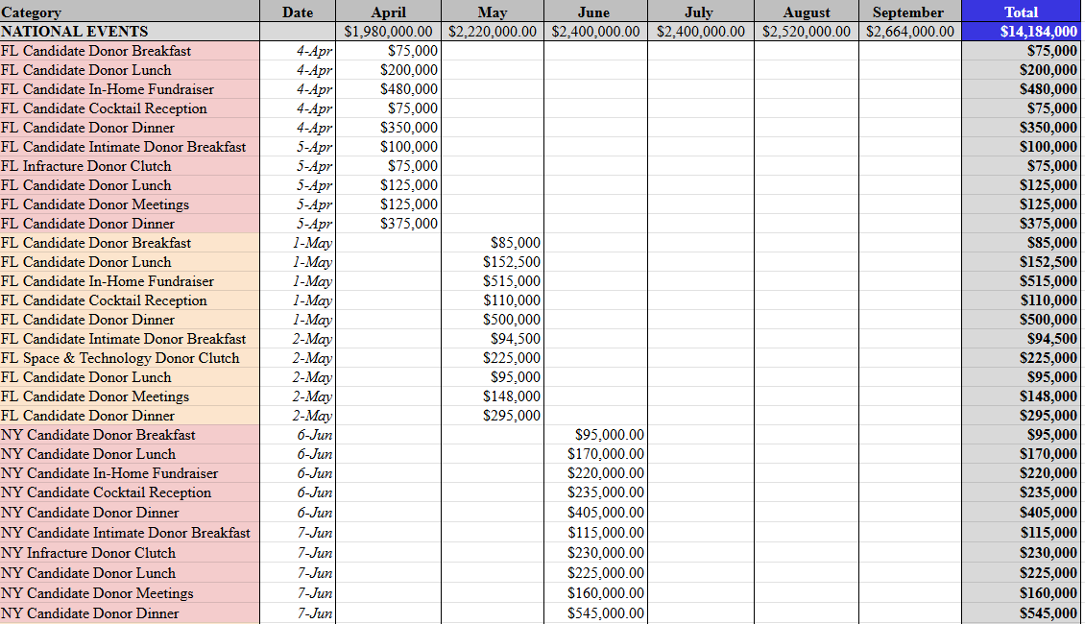
Q2 & Q3 National Travel Fundraising Breakdown

Digital Fundraising - 40% of Total Budget ($32,000,000)
Only 40% of the total budget will come from digital fundraising because Republican candidates usually raise less money from online contributions. It will cost $8 million to raise this $32 million, for a net revenue of $24 million.

Sample Fundraising Email Copy
From: Mike Collins [info@mikecollins.com]
Sent: June 25, 2026
Subject: Outspent by Ossoff
Georgia,

I’m in Congress working hard for Georgia families. That’s what I’ll keep doing as your Senator, but I can’t deliver for you if we keep getting outspent in this election. Right now, thousands of donors from out of state are pouring millions of dollars into Jon Ossoff’s campaign. Democrats from California and New York are trying to use Georgia families for their own goals. As your senator, I’ll only have one interest: working for you. Together, we can stop outside spending from taking over Georgia. Don’t let the elites overpower your voice. It’s time to join the fight for Georgia. Thousands of supporters have already donated. Before this week’s fundraising deadline, can you donate $3 or more to protect Georgia families?

Sample Facebook Fundraising Advertisement Copy
Hey y’all,
Let’s show the liberal elite that Georgia voters want someone who will fight for Georgia families in Congress.

Click on the link below to personally endorse my campaign for the U.S. Senate. Let’s get signatures from every county and as many Georgians as possible to show we won’t back down from the fight to protect our state.

This ad would lead to a form collecting names, zip codes, email addresses, and phone numbers to build a fundraising list.

Corporate and Special Interest PAC Contributions - 12.5% of Total Budget ($10,000,000)
We estimate that 12.5% of our total budget will come from Corporate and Special Interest PACs. As a Republican candidate, Mike Collins’ campaign can expect higher PAC funding compared to a similar Democratic campaign. In his House races, and as a Member of Congress, Mike Collins readily accepted Corporate PAC money. For this campaign, he can expect to receive funding from large employers in the area and industries with interest in the area. For example, Meta, the social media organization and Caterpillar, the heavy-industry company will both contribute to the campaign as Caterpillar has a major production facility in Georgia and Meta recently built a large data center for AI support in rural Georgia. Support from Caterpillar aligns not only with Rep. Collins’ existing committee assignment focusing on infrastructure, but also his campaign priority of returning manufacturing jobs to Georgia.

Rep. Collins can also expect Corporate PAC money aligning with his other committee assignments focusing on transportation, including from automakers who have and are building plants in Georgia, like Hyundai, and energy companies relating to his work with the environment. Rep. Collins will also receive PAC money from single interest groups and ideological organizations that align with his work on immigration control and crime. Finally, as this is a competitive race and important for Republicans to flip in order to increase their margins in the Senate, Rep. Collins can expect some money from Leadership PACs from conservative Members of Congress.

Direct Mail- 7.5% of Total Budget ($6,000,000)
Contributions from direct mail will account for 7.5% of revenue. Donations from both checks and online donations through QR codes on physical mailers will comprise this portion. Republican voters across the country are older and are more inclined to donate through direct mail fundraising tactics rather than online websites or emails. It will cost $180,000 to raise this $6 million.

Expense Allocation by Category

Paid Media - $60,458,297
TV and Radio advertising will account for 77% ($46,418,297) of paid media. Since our campaign is targeting an older audience, TV advertisements will have a higher effectiveness of reaching our target voters, so Broadcast and Cable account for a majority of the budget and radio will account for the remainder. The Cost Per Point (CPP) for both TV and Radio was calculated based on a blend of dayparts to optimize our messages reach to the intended audiences while accounting for cost differentials for each daypart. For Radio advertisements in unincorporated areas, we used the CPP of Columbus (the least expensive market) to simulate the CPP in these areas.

Digital advertising will account for 23% ($14,040,000) of paid media. This will be further broken down into five subcategories. CTV is 40% of the digital budget, OLV (Online TV & Streaming) and Youtube are 35%, social media will be 15%, audio will be 9.5%, and search will be 0.5%.

Mail & Print- $5,256,000
We will spend $5,256,000 on fundraising and persuasion mail. A majority, $5,076,000.00, will be spent on persuasion mail to reach voters of target audiences multiple times with multiple messages throughout the campaign. The creation and dissemination of fundraising mail, and therefore costs, will begin in June.

Payroll - $4,568,750
Payroll for employees will cost $4,568,750 across the course of the campaign. This cost is derived from each employees’ monthly salary and health insurance fees. Employees will be brought onto the campaign on a rolling basis as need arises for more staff. Employees will be paid through to the end of December regardless of the outcome of the election.

Field- $510,500
We have allocated $510,500 for field expenses such as office rentals, operating expenses, and office expenses. This does not include salary for field staff. Field operations will open on a rolling basis through the first six months of the campaign, so the costs will follow the same pattern of increase.

Polling and Research- $879,000
The polling and research budget includes $25,000 for self-opposition research in addition to $50,000 opposition research against Jon Ossoff. The remainder of the budget will be dedicated to polling which will be done consistently throughout the campaign cycle at various times. The polling will consist of a schedule of benchmark polling, baseline polling, and brushfire polls at appropriate times to ensure that the campaign’s messaging is resonating with the electorate and to ensure that the target audiences are being reached. Finally, the campaign will conduct focus groups to test messaging with specific audiences.

The campaign will conduct three benchmark polls in February and June to comprehensively review the target audiences and make changes as needed. Each benchmark poll will cost $100,000 for a total of $200,000. The campaign will conduct four baseline polls in May, July, August, and September to ensure that messaging remains on track during these periods. Each Baseline poll will cost $75,000 for a total of $300,000. The campaign will conduct four Brushfire polls in every week of October to gauge position ahead of the election. Each brushfire poll will cost $50,000 for a total of $200,000. Finally, the campaign will conduct two sets of four focus groups with specific targeted demographics in March and June to ensure that our messaging tests well with these groups. Each focus group costs $13,000 for a total per session of $52,000, and a total focus group budget of $104,000.

Compliance- & Legal $550,000
We will hire an outside firm to ensure our fundraising reporting is compliant with all Federal Election Commission guidelines. Responsibilities include, but are not limited to, processing incoming revenue from small dollar and major donor donations, preparing and filing disclosure reports, and managing a record of all donations. This firm will be hired in January and kept on board throughout the entire campaign. They will be paid $25,000 monthly for a total of $275,000.

We will keep a law firm on retainer throughout the campaign to ensure the campaign does not violate the law at any time in any aspect. This firm will be paid $25,000 monthly for a total of $275,000.

Calendar
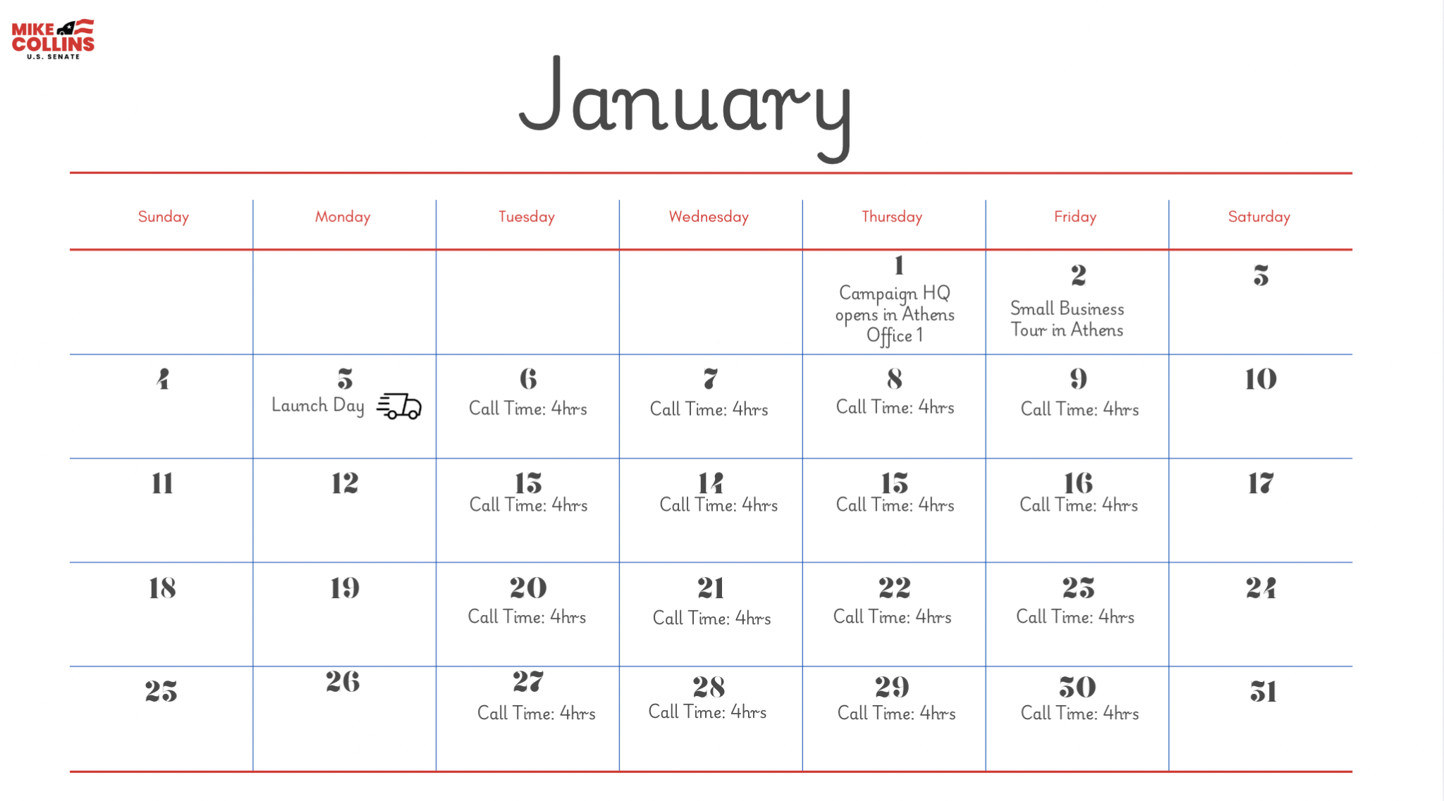

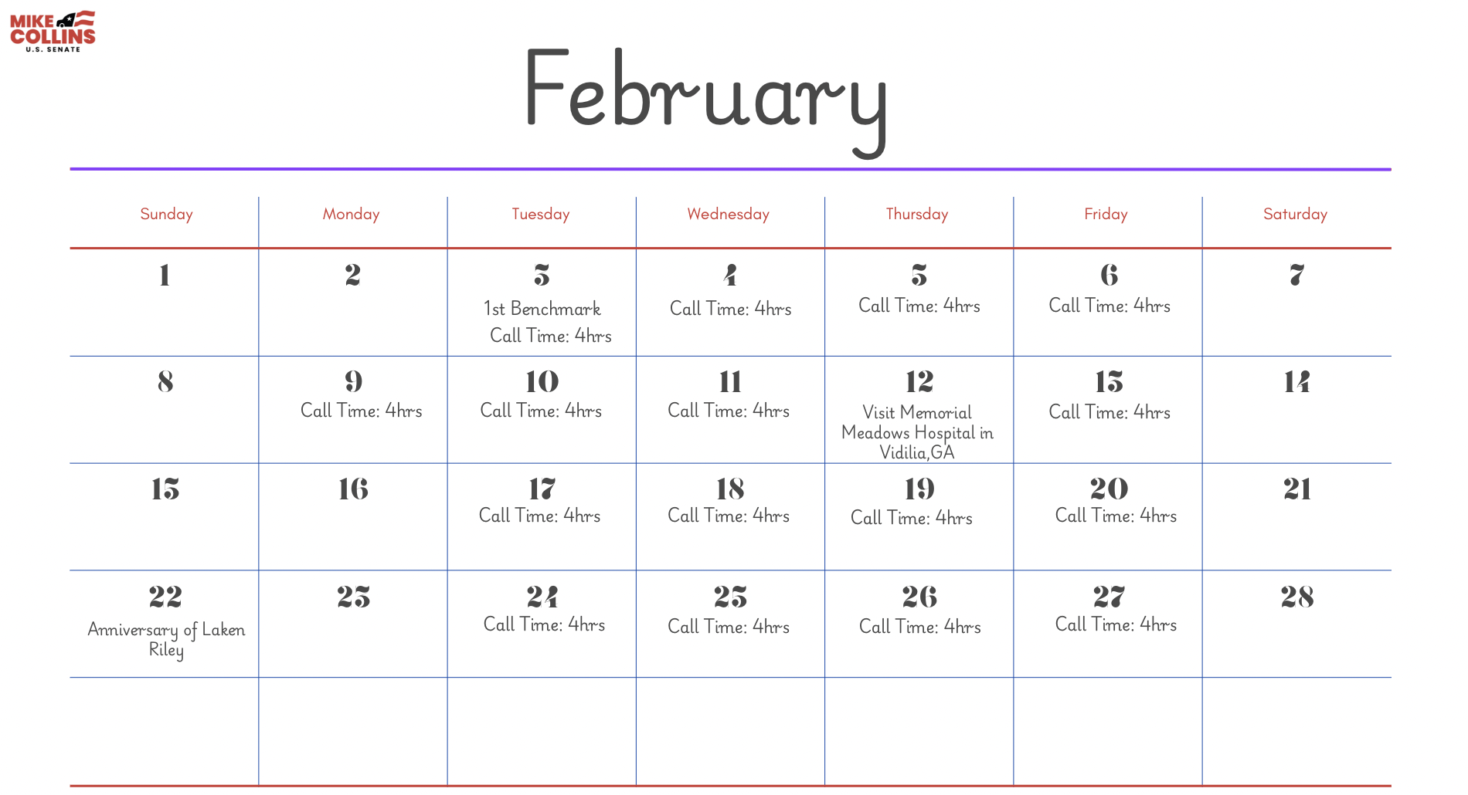

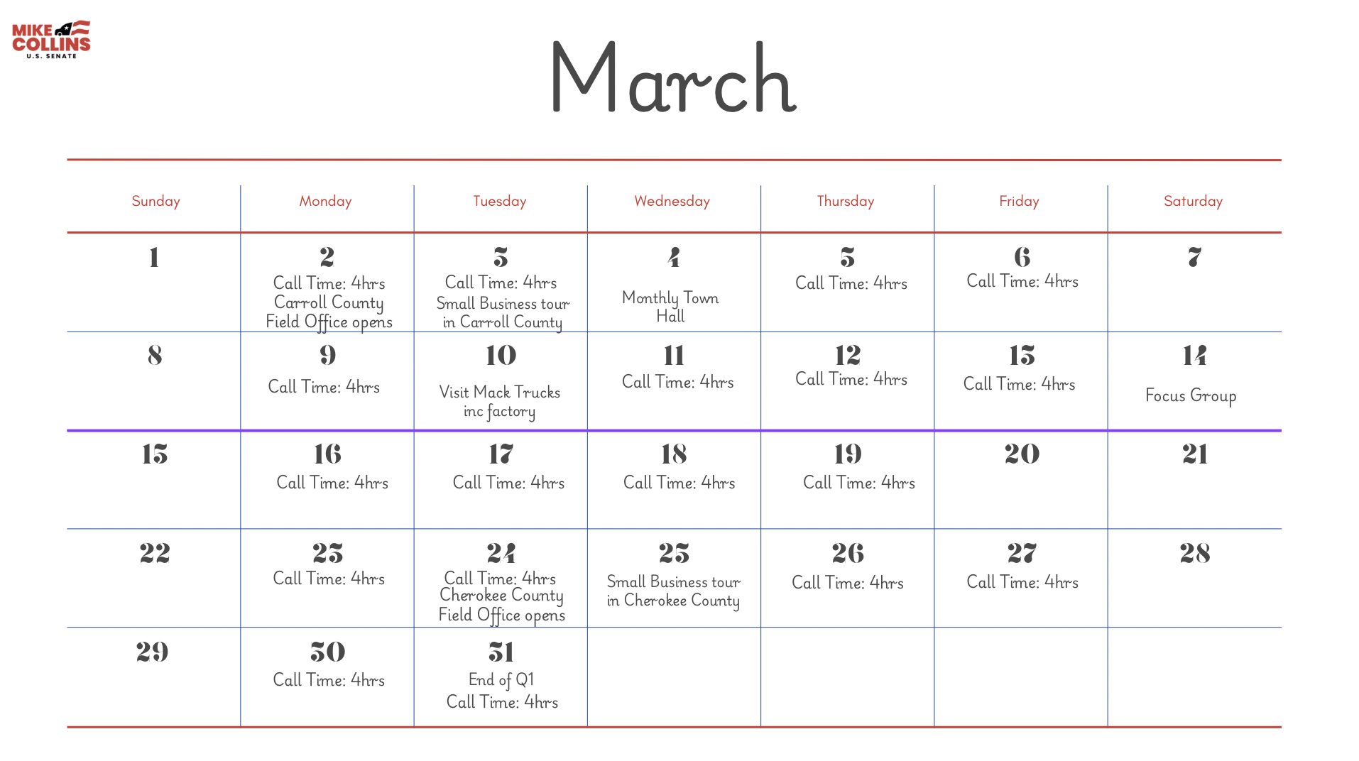
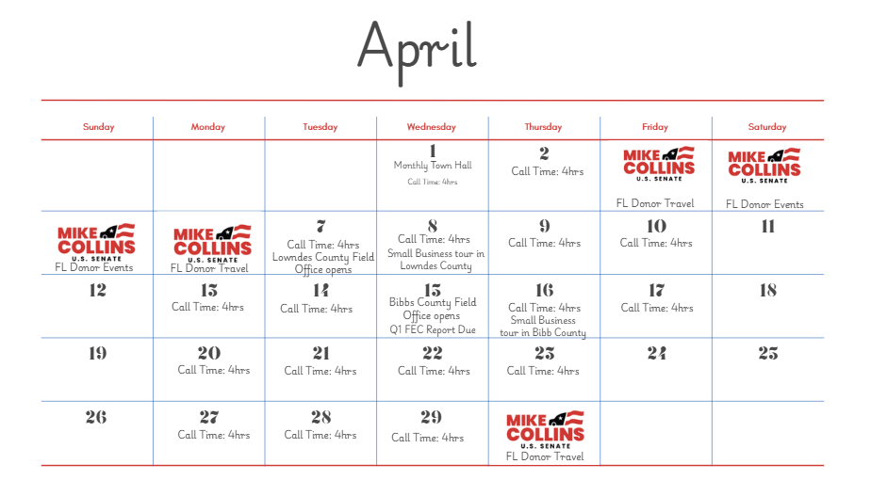
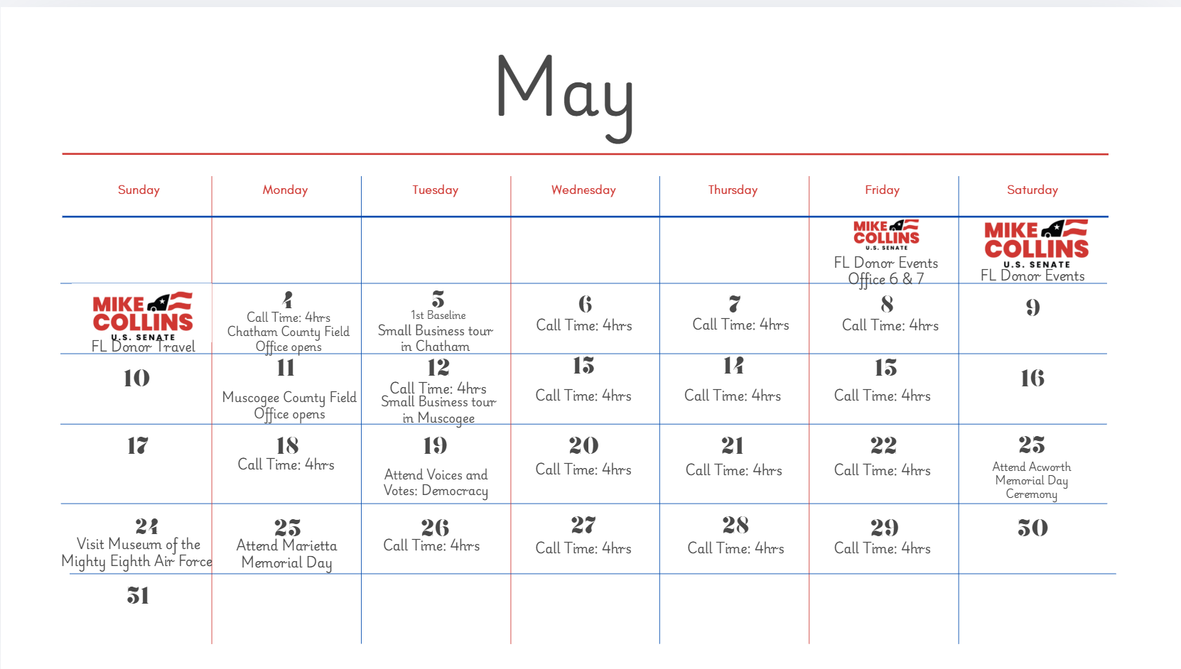

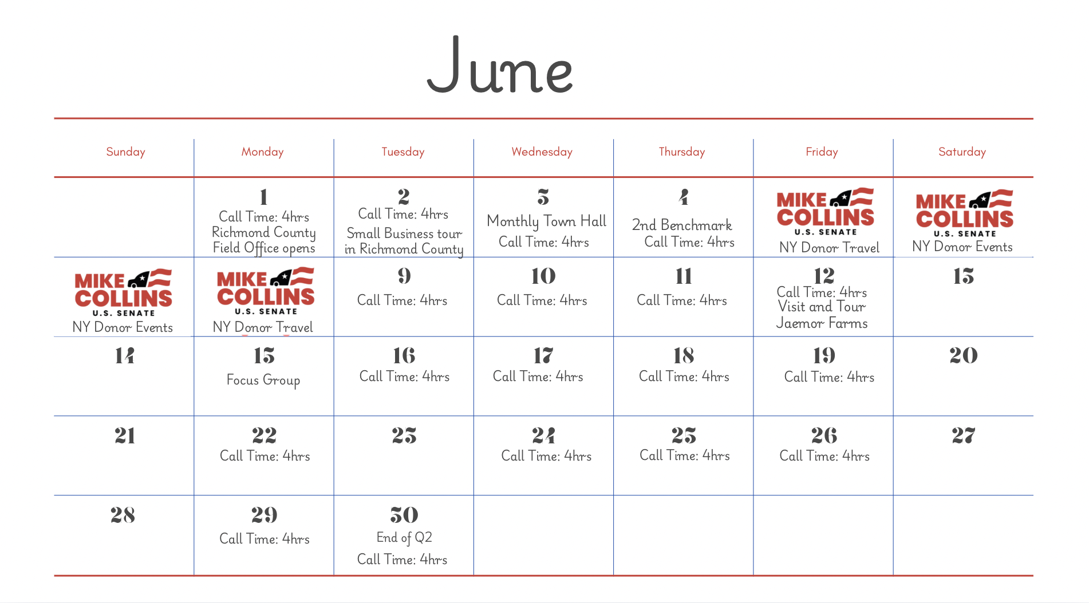

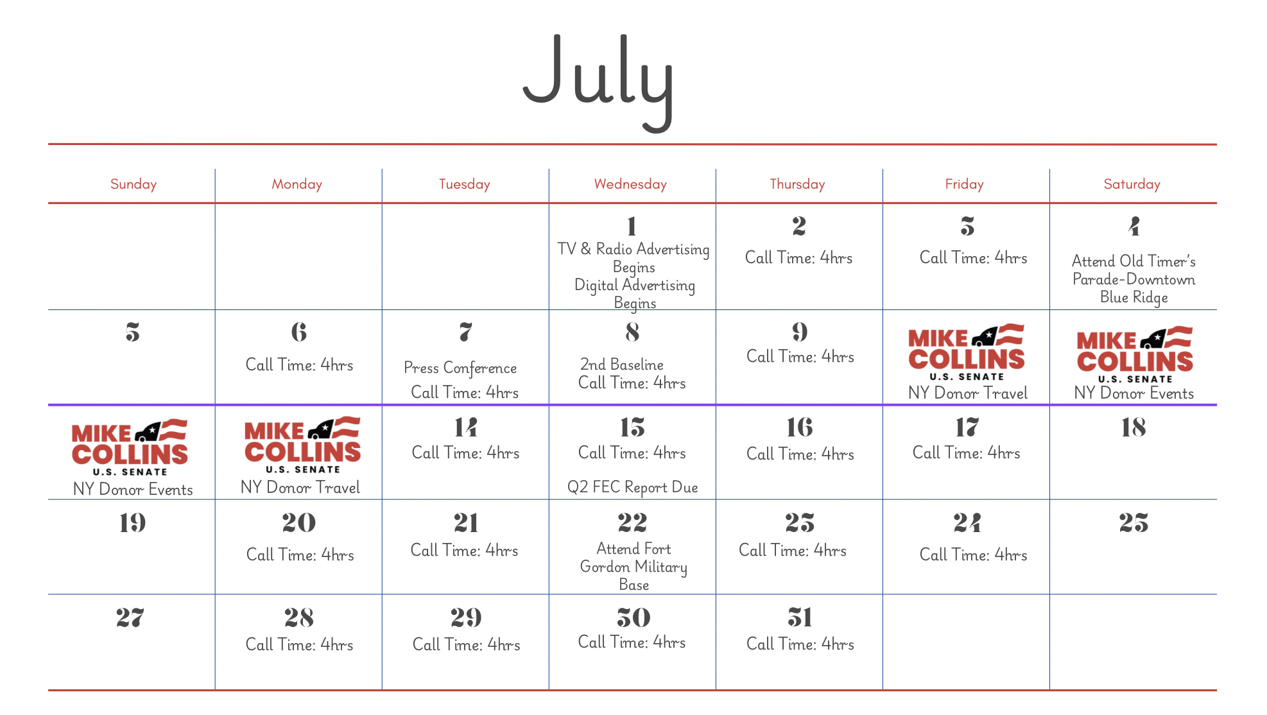
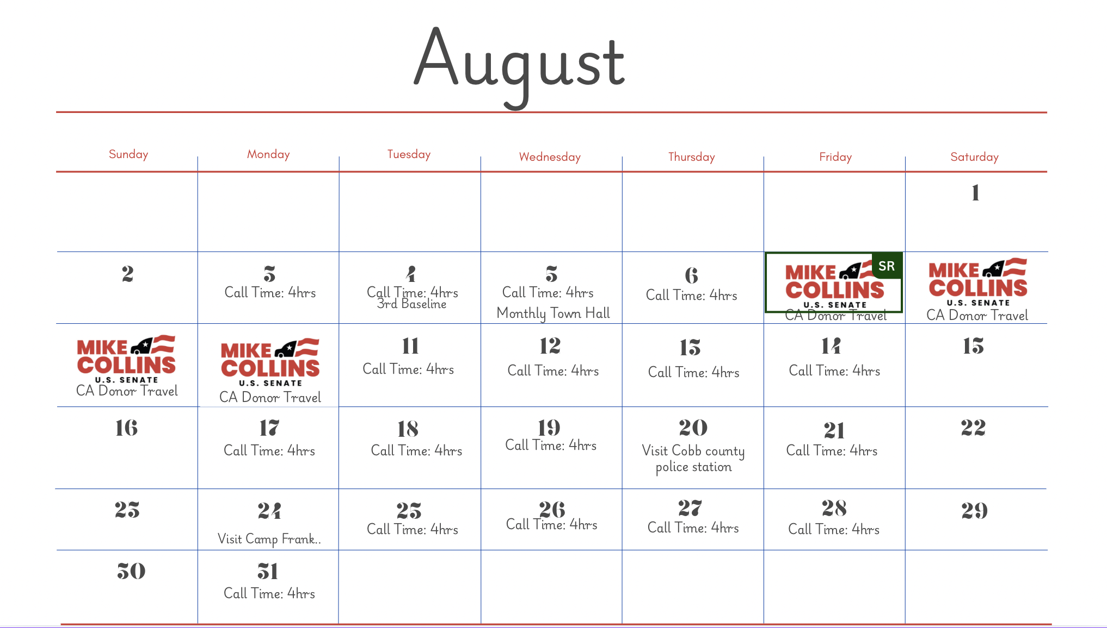
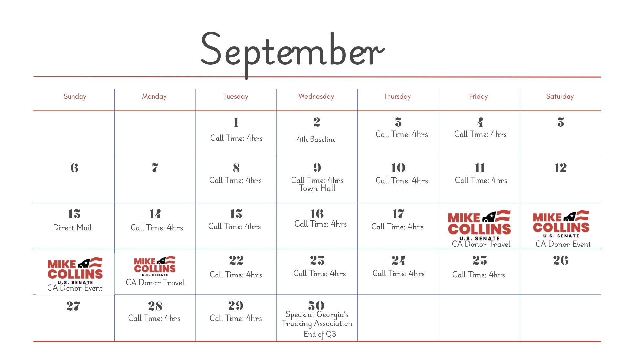

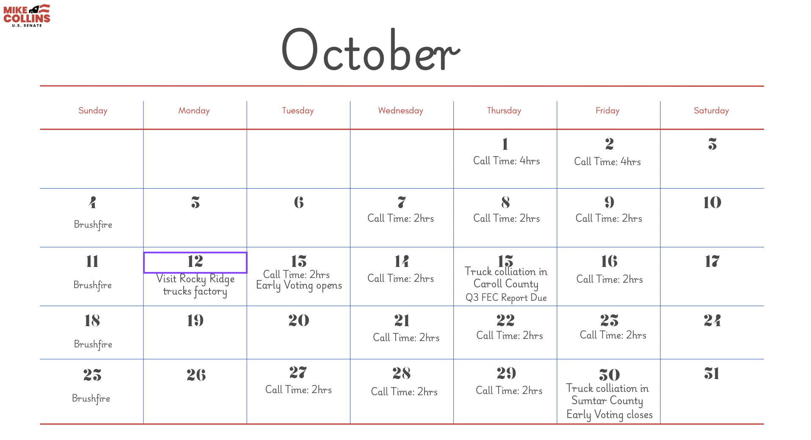
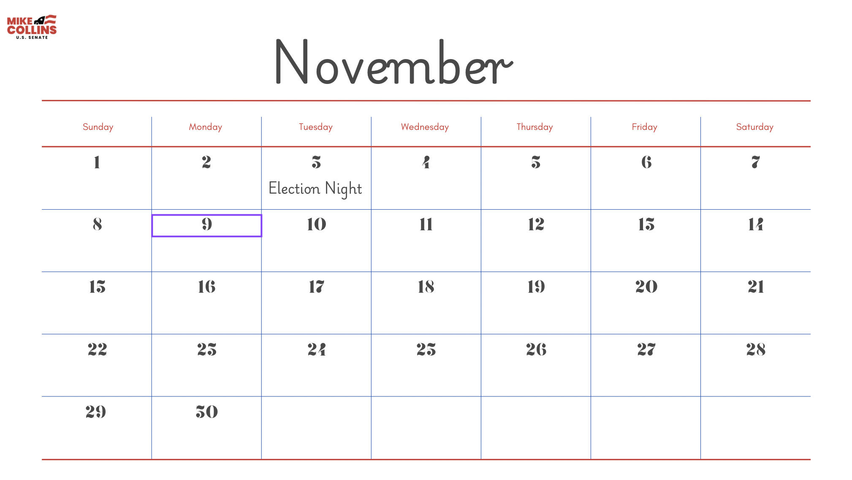

Appendix

Announcement Speech
Speaker: Mike Collins
Venue: Rally in Jackson, Georgia. Appx 300-400 attendees. Ranch/barn/wide open rustic venue

Hello Georgia,

If you don’t know me already, I’m Mike Collins; I was born and raised right here in Jackson, and I come from a family of hard-working Georgians. This town is where I met my lovely wife Leigh Ann, and where I started my own small business. I have been living and working in Georgia my whole life, and for the past three years, I’ve been working for Georgia in Congress.

Today, I’d like to tell you a little about my first job. Before I married my high-school sweetheart, before I started my own business, and before I sponsored my first piece of legislation, I was sweeping the floors of my dad’s shop after school. At 12 years old, the dusty broom I used was as tall as I was. Eventually, I grew taller than that broom, and along the way, I learned the value of a strong work ethic, and the impact even one person can have on the world around them.

I carried that lesson with me as I grew my small trucking business from operating just one truck, to employing over a hundred people. I carried that lesson with me to Washington where I wrote two pieces of legislation that were passed and signed into law by two presidents of two different parties. I still carry that lesson with me every day because you deserve someone in Congress who works as hard as you do.

You need more than a worker though, Georgia, you need a fighter. Georgians are tired of politicians who won’t fight for them. Politicians who don’t know what it's like to have government regulations suffocate your businesses when you’re already worked to the bone. I’ve lived it with my own business. My employees depend on me for a paycheck. Our communities depend on the government to just get out of the way. I know what it’s like to create jobs for Georgians. Career politicians do not.

That’s why I’m joining the fight to be your Georgia Senator. You need someone who knows the struggles of everyday life. Someone who sees the problems you face and actually does something about them.

We can’t carry on business as usual. Unchecked property taxes are pricing us out of our homes, and out of state buyers are only making the housing market more expensive. I have seven grandkids. I want them to be able to pursue the American dream like I have, and like my father did before me. Georgia should be a place we can all share with our children and grandchildren, not an old faded memory of someplace that became too expensive to live. To protect the Georgia we know and love, we cannot rely on Jon Ossoff as our voice in the Senate.

As your senator, you will be my first priority. I will fight everyday to make your lives and our state safe and prosperous. And that’s not an empty promise. I have the experience, and the work ethic to win this fight. Georgia, I am ready to deliver results for our families and our communities. If that young boy who started out sweeping floors for his dad’s business can end up passing some of the most significant legislation to protect Americans’ safety, then imagine what we can all do together. If you’re ready to see someone in the Senate work for you, then hop on board. We’ve got a long road ahead, but I’m ready to roll.

Budget Screenshots
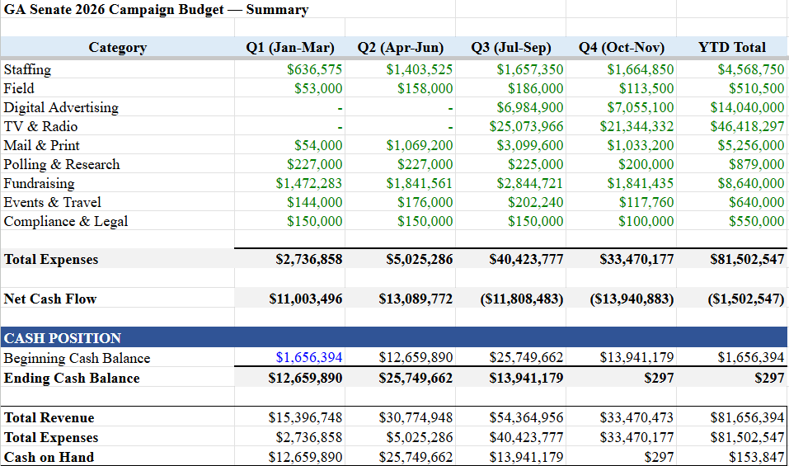
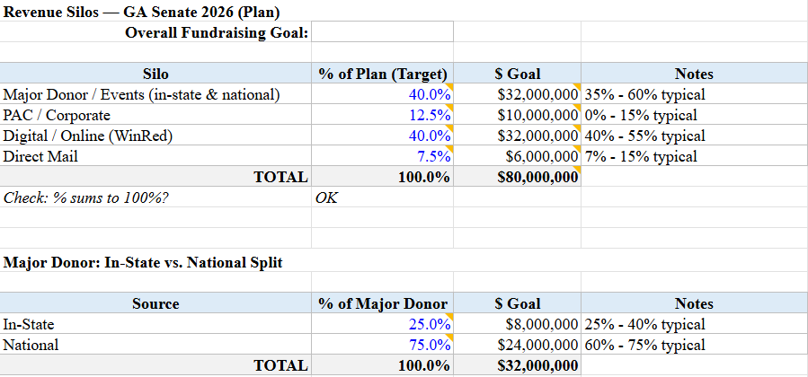

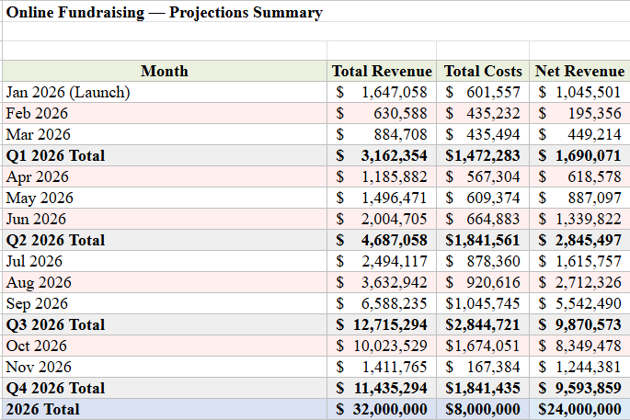
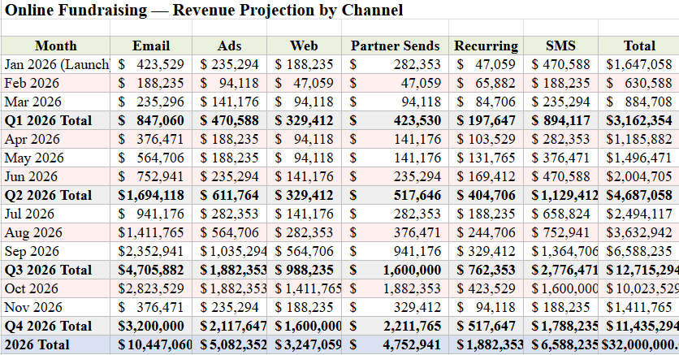
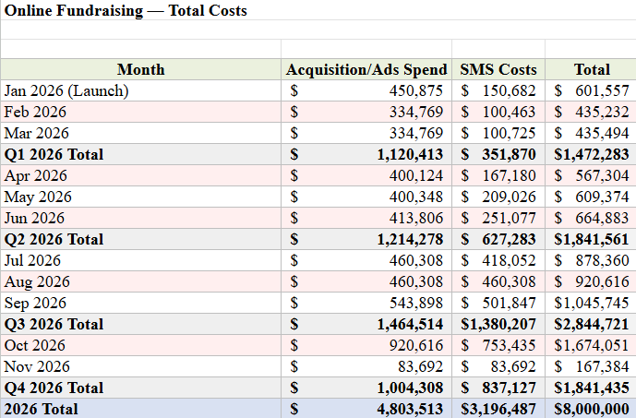
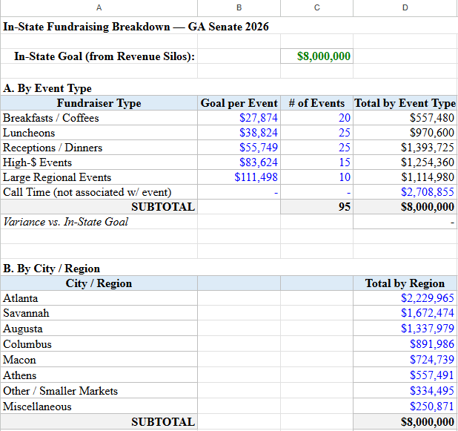
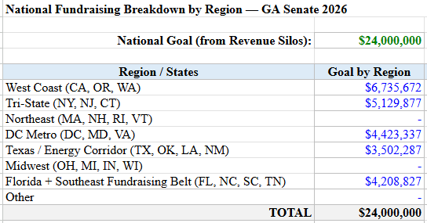
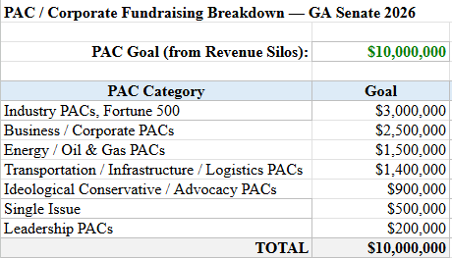
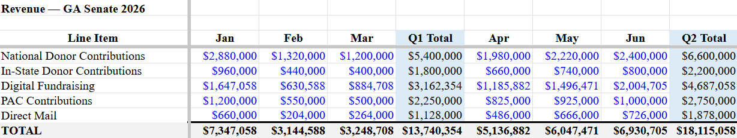
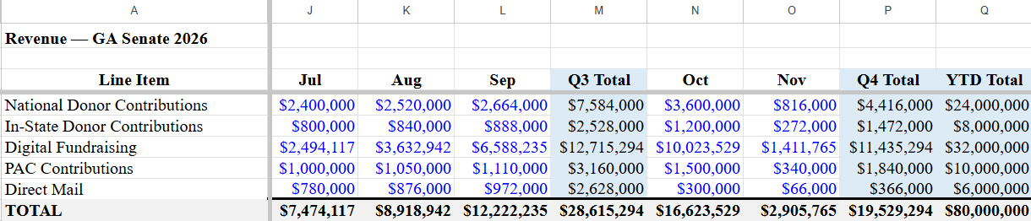

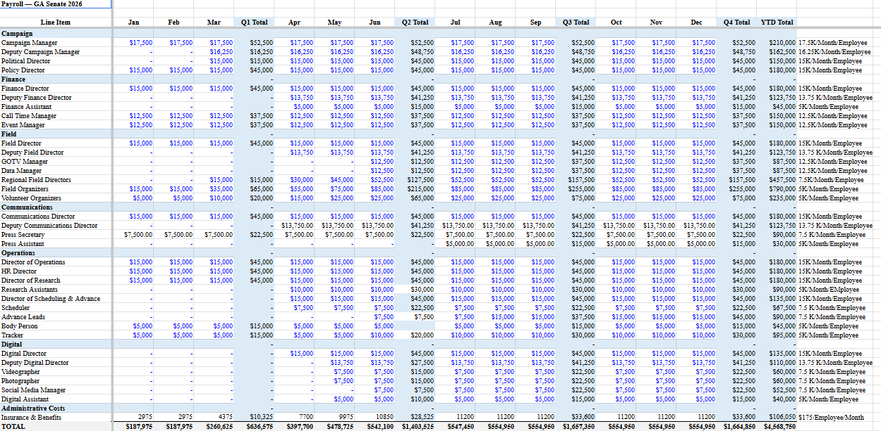
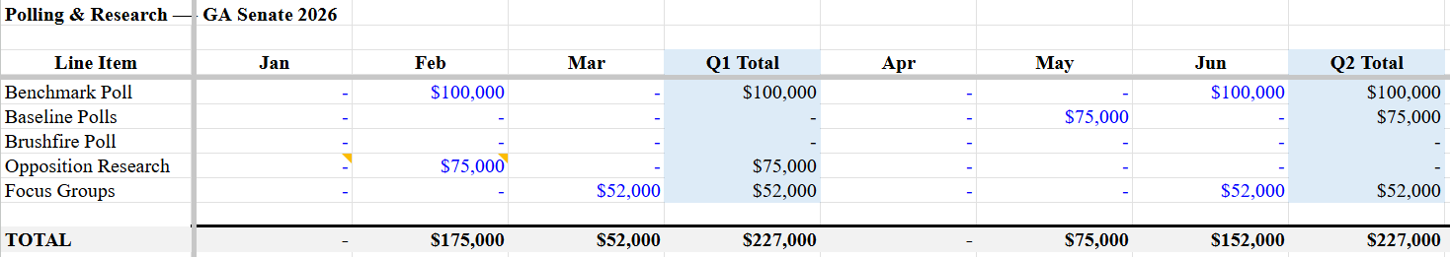
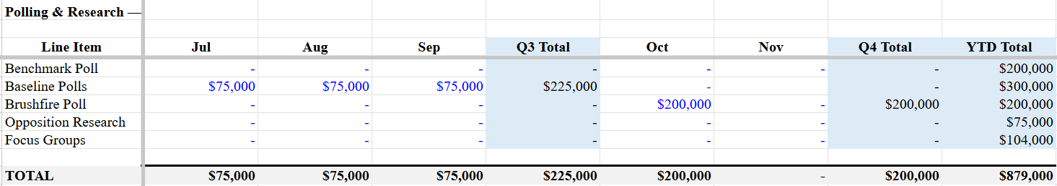
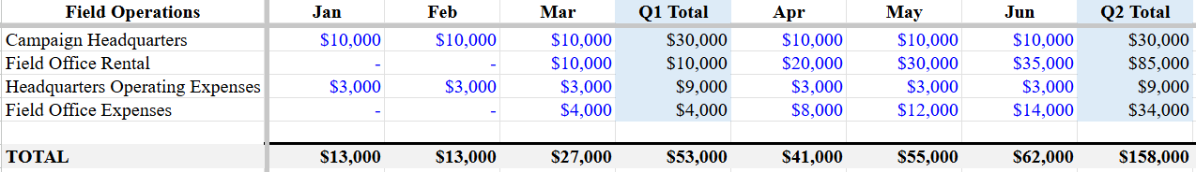
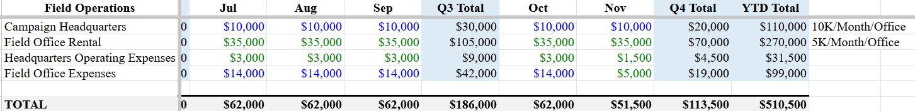
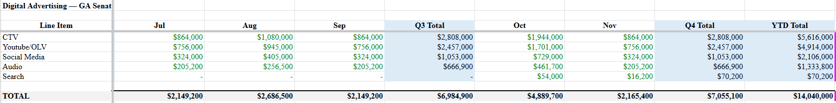
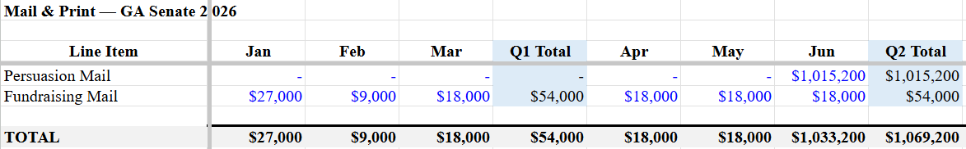
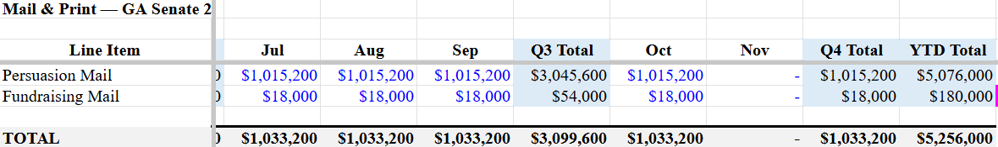
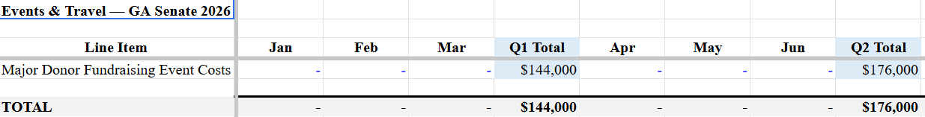
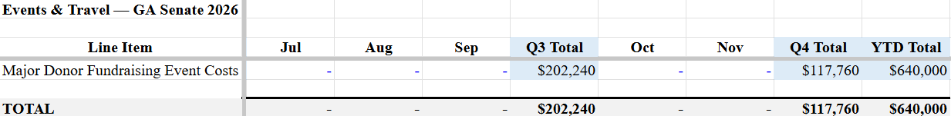
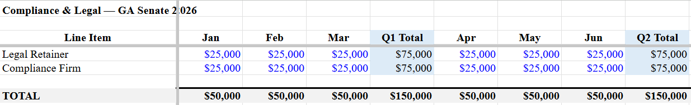
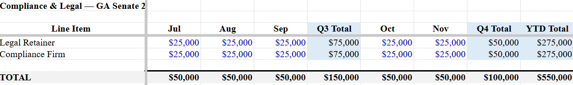

https://www.haistenfuneral.com/obituary/Michael-Collins
https://www.ciclt.net/sn/leg_app/po_detail.aspx?ClientCode=slt&P_IDEO=gaush10&utm
https://www.haistenfuneral.com/obituary/Michael-Collins
https://www.haistenfuneral.com/obituary/Michael-Collins
https://mikecollinsga.com/about/
https://mikecollinsga.com/about/
https://www.geotab.com/blog/truck-driver-salary/
https://collinstrucking.com/faq/
https://mikecollinsga.com/about/
https://www.congress.gov/bill/119th-congress/senate-bill/5
https://www.congress.gov/member/mike-collins/C001129?q=%7B%22sponsorship%22%3A%22sponsored%22%2C%22type%22%3A%22bills%22%7D
https://mikecollinsga.com/about/
https://collins.house.gov/media/press-releases/rep-mike-collins-reintroduces-security-and-fairness-enhancement-america-act
https://www.redandblack.com/athensnews/u-s-rep-mike-collins-generates-controversy-with-jan-6-tweet/article_ecf252aa-cefe-11ef-bf8c-7bd16eccce8e.html][https://www.irishstar.com/news/us-news/mike-collins-video-ballot-boxes-34012545
https://collins.house.gov/media/press-releases/collins-votes-protect-children-and-condemn-violence-against-pro-life
https://clerk.house.gov/Votes/2023528
https://x.com/RepMikeCollins/status/1681685437075660808
https://clerk.house.gov/Votes/2023136
https://apnews.com/article/ukraine-funding-taiwan-us-china-military-8cbb671399a51e0e34b9e40f72f51e56
https://georgiarecorder.com/2023/05/31/u-s-house-approves-debt-limit-package-sending-it-to-senate-days-before-default-deadline/
https://mikecollinsga.com/endorsements/
https://www.senate.gov/senators/117thCongress/ossoff-jon.htm
https://electjon.com/bio/
https://www.govtrack.us/congress/members/jon_ossoff/456857/report-card/2024
https://electjon.com/bio/
https://www.ossoff.senate.gov/about/
https://www.ossoff.senate.gov/about/
https://news.gallup.com/poll/651719/economy-important-issue-2024-presidential-vote.aspx
Politics of Georgia (U.S. state) - Wikipedia
2020 United States presidential election in Georgia - Wikipedia
2024 United States presidential election in Georgia - Wikipedia
https://emersoncollegepolling.com/georgia-2026-poll-senator-ossoff-starts-re-election-near-50-and-outpaces-gop-field/
https://www.washingtonpost.com/elections/interactive/2024/georgia-exit-polls/
https://www.cbsnews.com/atlanta/news/kemp-signs-2-tax-cut-bills-delivering-savings-for-georgia-families-and-homeowners/
https://www.cbsnews.com/news/scotus-ruling-ushers-in-a-new-era-of-gerrymandering/
GA County Master w_ Media Market workbook
Strong R counties at Low and Mid turnout tiers, filtered from county_data_with_markets cols BA (lean_bucket) and BB (turnout_tier).
Active voters: county_data_with_markets col X (active_voters_2026). Mobilization universe: col BC (mobilization_universe), summed across the 56 Strong R Mobilize counties.
GA County Master workbook, Summary tab cell B9
county_data_with_markets, Cobb County row, col BB (persuasion_universe)
https://law.justia.com/codes/georgia/title-21/chapter-2/article-12/section-21-2-501/
Summary tab cell B6
Summary tab cell B7
Summary tab cell B10
county_data_with_markets col BA (lean_bucket)
County_data_with_markets col X (active_voters_2026), summed
https://sos.ga.gov/page/election-results-2022
https://sos.ga.gov/page/election-results-2022
https://www.cnn.com/2022/10/25/politics/georgia-senate-warnock-walker-kemp/index.html
https://www.nytimes.com/2022/11/04/upshot/georgia-senate-kemp-walker.html
Cobb County row in county_data_with_markets: col AX (partisan_blend_r), col AW (kemp_walker_gap_pts), col X (active_voters_2026), col BB (persuasion_universe)
Summary tab column J: formula =G(persuasion universe per county) multiplied by Summary!B10 (the 31% conversion rate needed). Sum of col J across all 159 counties equals Summary!B8, the total gap to 52%.
Statewide demographic shares calculated from county_data_with_markets cols AG-AM (reg_2020_*) summed and divided by total active voters
county_data_with_markets cols AB (turnout_2020_white_female) and AC (turnout_2020_white_male), weighted by active voters
county_data_with_markets cols AL (reg_2020_hispanic) and AE (turnout_2020_hispanic) for Hall, Whitfield, and Barrow rows
county_data_with_markets cols Z (turnout_2020_black_female) and AA (turnout_2020_black_male)
county_data_with_markets col BE (priority_rank)
https://mikecollinsga.com/endorsements/
https://mikecollinsga.com/endorsements/
https://www.congress.gov/bill/119th-congress/house-bill/8079
https://www.congress.gov/bill/119th-congress/house-bill/3679
https://www.usatoday.com/story/news/2026/05/05/trumps-approval-remains-high-in-georgia-as-voters-head-to-the-polls/89942430007/
https://www.ajc.com/politics/trumps-support-sinks-in-georgia-as-economic-fears-rise/UVF4TQWIVNGBXCBNBPCWYX7YLI/
https://www.propublica.org/article/mike-collins-georgia-senate-truck-crashes
https://www.ajc.com/politics/2026/01/the-man-behind-mike-collins-rise-now-faces-mounting-scrutiny/
https://www.politico.com/news/2022/12/13/gop-operative-brandon-phillips-00073724
https://people.com/congressman-mike-collins-misspells-home-state-of-georgia-in-campaign-ad-11781464
https://emersoncollegepolling.com/georgia-2026-poll-senator-ossoff-starts-re-election-near-50-and-outpaces-gop-field/
https://www.pewresearch.org/religious-landscape-study/state/georgia/
https://www.congress.gov/member/mike-collins/C001129
https://www.congress.gov/member/mike-collins/C001129
https://www.congress.gov/member/mike-collins/C001129
https://web.archive.org/web/20170222084607/https://electjon.com/news/2017/1/4/jon-ossoff-announces-congressional-bid-in-georgia
ttps://ballotpedia.org/Supplemental_Nutrition_Assistance_Program_work_requirements_during_the_Biden_administration
https://www.youtube.com/watch?v=Z1viRjFPZ1Q
https://www.smh.com.au/world/north-america/almost-australian-the-georgia-run-off-candidate-with-roots-down-under-20210106-p56s01.html
https://www.congress.gov/member/jon-ossoff/O000174
https://www.opensecrets.org/profiles/jon-ossoff/us_congress/summary?mpid=1124497
https://www.nbcnews.com/politics/politics-news/gen-z-using-tiktok-encourage-youth-voter-turnout-georgia-s-n1252787
https://apnews.com/article/georgia-senate-2026-jon-ossoff-democrat-dde4e55d7d2e12e6fc166f436a83ea8c
https://www.congress.gov/member/mike-collins/C001129
https://www.congress.gov/member/mike-collins/C001129
https://senatemajority.com/news/buddy-carter-and-mike-collins-side-with-president-trump-with-their-vote-to-keep-prices-sky-high/
https://www.ossoff.senate.gov/about/
https://providers.emoryhealthcare.org/provider/alisha-sara-kramer/3098839
https://www.gachamber.com/news/georgia-chamber-announces-legislative-endorsements-for-the-2022-midterm-election/?utm_source=chatgpt.com
https://www.pewresearch.org/internet/2025/11/20/americans-social-media-use-2025/pi_2025-11-20_social-media-use_0-03/
https://www.scientificamerican.com/article/why-gen-z-men-voted-for-trump/
https://www.pewresearch.org/internet/2024/01/31/americans-social-media-use/
https://www.forbes.com/sites/maryroeloffs/2024/04/30/americans-listen-to-far-more-radio-than-podcasts-even-young-people-new-data-shows/
https://www.pewresearch.org/politics/2024/04/09/age-generational-cohorts-and-party-identification/
https://www.nytimes.com/2024/09/27/us/politics/republican-candidates-wives-ads.html
https://www.cnbc.com/2024/11/21/how-trumps-win-was-helped-in-part-by-young-mens-financial-struggles.html
https://apnews.com/article/shutdown-snap-benefits-food-assistance-stigma-race-4bf5074c920e601e80e931cb5a22a784

